Client: | CTICM/ARCELORMITTAL
Order reference: | Order N° 45584318 on 23/12/22  and contract AM/CTICM on 12/01/23
Project Index:  Product Index: | DRV/DAL-22-003/002-A  DRV/PMX/MV/001-A
ABC-PMX-II Software
Composite beam design

validation manual
Membre du Comité de Coordination des Centres de Recherche en mécanique / Siret : 775 728 785 00046 Code Naf : 7219 Z

Revision | Date | Authors | Subject
A | 26/01/2024 | G. DELACOURT | ABC-PMX-II Software – Validation Manual
B
C
D

Content
1. Introduction 3
2. References 3
2.1. First generation of Eurocodes 3
2.2. Drafts for the second generation of Eurocodes 3
2.3. Scientific references 3
3. Principles of validation 4
4. Scope grid 5
5. Tests cases – Composite beams 7
5.1. CASE C01: Single span composite beam 7
5.1.1. Description 7
5.1.2. Parameters 7
5.1.3. Verification of results 9
5.2. CASE C01b: Simply supported composite beam 12
5.2.1. Description 12
5.2.2. Parameters 12
5.2.3. Verification of results 12
5.3. CASE C02: Single span composite beam laterally restrained during its construction phase 13
5.3.1. Description 13
5.3.2. Parameters 13
5.3.3. Verification of results 14
5.4. CASE C03: Single span composite beam with partial encasement (construction phase) 15
5.4.1. Description 15
5.4.2. Parameters 15
5.4.3. Verification of results 18
5.5. CASE C04: Single span composite beam with partial encasement (composite phase) 21
5.5.1. Description 21
5.5.2. Parameters 21
5.5.3. Verification of results 22
6. Tests cases – Steel beams 37
6.1. CASE S01: Steel beam with 2 cantilever spans 37
6.1.1. Description 37
6.1.2. Parameters 37
6.1.3. Verification of results 39
6.2. CASE S02: Steel beam with welded profile 42
6.2.1. Description 42
6.2.2. Parameters 42
6.2.3. Verification of results 44
6.3. CASE S02b: Steel beam with welded profile 46
6.3.1. Description 46
6.3.2. Parameters 46
6.3.3. Verification of results 47
6.4. CASE S03: Steel beam with welded profile and MV interaction 49
6.4.1. Description 49
6.4.2. Parameters 49
6.4.3. Verification of results 51
6.5. CASE S03b: Steel beam with welded profile and MV interaction 53
6.5.1. Description 53
6.5.2. Parameters 53
6.5.3. Verification of results 53
6.6. CASE S04: Steel beam with welded profile and interaction between bending and shear buckling 55
6.6.1. Description 55
6.6.2. Parameters 55
6.6.3. Verification of results 57
6.7. CASE 6: Simply supported composite beam with welded steel section 59
6.7.1. Description 59
6.7.2. Parameters 59
6.7.3. Results 67

Introduction
ABC-PMX software aims at the calculation of composite beams according to EN 1994-1-1. Its development is co-funded by ArcelorMittal and CTICM. This documents constitutes the Validation Manual.

References

First generation of Eurocodes
- EN 1990 – Basic of structural design. AFNOR. March 2003.
- EN 1991-1-2: Eurocode 1: Actions on structures Part 1-2: General actions — Actions on structures exposed to fire
- EN 1992-1-1 – Design of concrete structures. Part 1-1: General rules and rules for buildings. AFNOR. October 2005.
- EN 1993-1-1 – Design of steel structures. Part 1-1: General rules and rules for buildings. AFNOR. October 2005.
- EN 1993-1-2 – Design of steel structures. Part 1-2: General rules - Structural fire design
- EN 1993-1-5 – Design of steel structures. Part 1-5: Plated structural elements. AFNOR. March 2007.
- EN 1994-1-1 – Design of composite steel and concrete structures. Part 1-1: General rules and rules for buildings. AFNOR. June 2005.
- EN 1994-1-2 – Design of composite steel and concrete structures. Part 1-2: General rules - Structural fire design

Drafts for the second generation of Eurocodes
- prEN 1992-1-1 – Design of concrete structures. Part 1-1: General rules and rules for buildings. Document SC2N2034
- FprEN 1993-1-1 – Design of steel structures. Part 1-1: General rules and rules for buildings. Document SC3 N3504 – 26/11/21
- FprEN 1993-1-5 – Design of steel structures. Part 1-5: Plated structural elements. Document SC3 N3728 – 26/11/21
- prEN 1994-1-1 – Design of composite steel and concrete structures. Part 1-1: General rules and rules for buildings. CEN/TC250/SC4 document N 2394. November 2021 - Draft.

Scientific references
- Design of floor structures for human induced vibrations. M. Feldmann, Ch. Heinemeyer, Ch. Butz, E. Caetano, A. Cunha, F. Galanti, A. Goldack, O. Hechler, S. Hicks, A. Keil, M. Lukic, R. Obiala, M. Schlaich, G. Sedlaceck, A. Smith, P. Waarts – Background document in support to the implementation, harmonization and further development in the Eurocodes – Joint Report – 2009 – JRC Scientific and Technical Reports
- European Recommandations for the Application of Metal Sheeting acting as a Diaphragm – Stresses Skin Design – ECCS European Convention for Constructional Steelwork – Report no 88 – 1995
- MARTIN P-O., RODIER A. - Design of the web-to-flange welds of a steel and concrete composite beam with a welded steel section – Revue Construction Métallique 1/2023
- MARTIN P-O., NGUYEN T-M. - Resistance to lateral torsional buckling of a secondary beam in construction phase – Restraint by the steel deck – Revue Construction Métallique 3/2022
- Déversement des poutres en acier – Collection CTICM (in French)
- Guide de conception pour les planchers minces à poutres incorporées - ECCS European Convention for Constructional Steelwork – Report no 83 – 1996
- COSFB Software – Technical specifications – 15/09/2020 – ArcelorMittal
- Nomogrammes – Méthode graphique pour déterminer la résistance au feu des structures en acier, selon l’EN 1993-1-2 :2005 – Centre Information Acier -

Principles of validation
This report includes test cases for all configurations. For each of them, the following are specified:
- the input data of the test case ;
- software output data ;
- the results obtained by the reference ;
- the comparison between the software output results and those obtained by the reference.
The input data is strictly identical between the software and the reference.
The references values used for software validation come from Excel spreadsheets developed specifically at CTICM and scientific literature references.
The comparison of the results is based on the evaluation of the differences between the values provided by the software and those of the reference. This comparison will be limited to the main results (verification ratios). The intermediate results will therefore be neither detailed nor compared here.
The analysis of the results obtained and the deviations observed makes it possible to confirm that the ABC-PMX-II software produces values in accordance with the calculation methods applied.

Scope grid
Parameters | Test C01 | Test C01b | Test C02 | Test C03 | Test C04
Type of section / beam | Composite beam | Composite beam | Composite beam | Composite beam / partial encasement | Composite beam / partial encasement
Type of profile | HR | HR | HR | HR | HR
Steel grade | S275 (EC3) | S275 (EC3) | S275 (EC3) | S355 M/ML | S355 EC3
Construction phase | No | yes | Yes | Yes | No
Propping | unpropped | unpropped | unpropped | unpropped | unpropped
Cantilever spans | No | No | No | No | No
Type of slab | Composite | Composite | Composite | Composite | Composite
Steel deck label | Cofraplus 60 | Cofraplus 60 | Cofraplus 60 | Cofraplus 60 | Cofraplus 60
Ribs orientations | Perpendicular | Perpendicular | Perpendicular | Perpendicular | Perpendicular
Restraint by the deck | - | - | Yes | No | No
Studs | 19-100 | 19-100 | - | - | 19-100
Standard | Generation 1 | Generation 1 | Generation 1 | Generation 1 | Generation 1
Type of design | Plastic | Plastic

Parameters | Test C05 | Test C05b
Type of section / beam | Composite beam | Composite beam
Type of profile | HR | HR
Steel grade | S355 JR | S355 JR
Construction phase | No | No
Propping | unpropped | unpropped
Cantilever spans | left | right
Type of slab | Composite | Composite
Steel deck label | Cofraplus 60 | Cofraplus 60
Ribs orientations | Perpendicular | Perpendicular
Restraint by the deck | - | -
Studs | 19-100 | 19-100
Standard | Generation 1 | Generation 1
Type of design | Plastic | Plastic

Parameter | Test S01 | Test S02 | Tests S03, S03b | Tests S04, S04b
Type of section / beam | Steel  beam | Steel  beam | Steel  beam | Steel  beam
Type of profile | HR | Welded | Welded unsymetrical | Welded unsymetrical
Steel grade | S355 M/ML | S355 JR | S275 JR | S460 EC3
Construction phase | - | - | - | -
Propping | - | - | - | -
Cantilever spans | Left and right | No | Left or right | Left
Type of slab | Solid | Solid | Solid | Solid
Steel deck label | - | - | - | -
Ribs orientations | - | - | - | -
Restraint by the deck | - | - | - | -
Studs | - | - | - | -
Standard | Generation 1 | Generation 1 | Generation 1 | Generation 1
Type of design | Plastic | Plastic | Plastic | Elastic
Shear buckling | No | Yes | No | Yes
Interaction MV | No | No | Yes | Yes
Interaction M shear buckling | No | No | No | Yes

Tests cases – Composite beams

CASE C01: Single span composite beam

Description
This test is based on the Construction Métallique review n°2018-2. It deals with a single span composite beam with a composite slab.
The reference values are taken from the paper. Because the calculation method of the software is more accurate, some values of the review may not match perfectly.
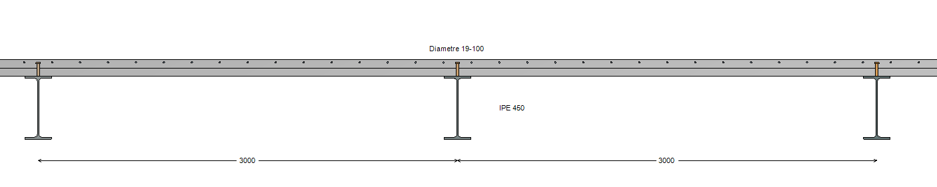
Figure 1 : Transversal view

Parameters
Definition of the beam:
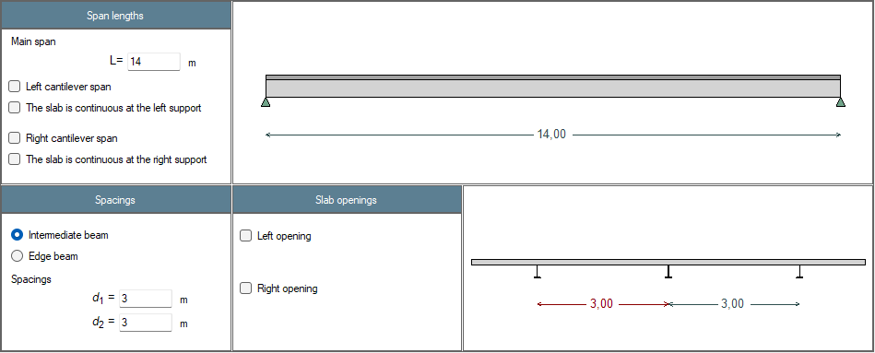

Definition of the slab:
Composite slab
Total depth: $t_{d}=120 mm$
Perpendicular ribs
Steel profiled sheeting: Cofraplus 60, thickness 0,75 mm
Prepunched sheeting

Definition of the profile:
Hot rolled profile
Profile: IPE 450
Steel grade: S275 EC3

Definition of the concrete:
Normal concrete
Concrete class: C25/30
Density: $ρ_{c}=2500 {kg/m}^{3}$

Definition of the connection:
Studs: 19x100
One stud in each rib
Unpropped beam during construction

Definition of loads:
G1: self-weight only
G2: surface load 1,4 kN/m²
live load Q1: surface load 2,5 kN/m²

Combination of loads:
ULS: 1,35 (G1+G2) + 1,5 Q1
SLS: (G1+G2) + Q1

Design parameters:
Standard: Eurocodes first generation
Design: According to the class of cross-section
Relative humidity: 50 %
Shrinkage deformation: 325 x 10⁻⁶
Age of concrete: $t_{0}=28 d$ for G2
t = 50 x 365 d

Verification of results
Case C01 Results: Steel profile | Reference | ABCPMX | Dev.
Cross-sectional area : $A$ = (cm²) | 98.8 | 98.8
Shear area : $A_{v}$ = (cm²) | 50.9 | 50.8 | 0.20%
Second moment of area (y-y axis) : $I_{y}$ = (cm⁴) | 33 740 | 33 743 | 0.01%
Second moment of area (z-z axis) : $I_{z}$ = (cm⁴) | 1 676 | 1 672 | 0.24%
Elastic section modulus (y-y axis) : $W_{el,y}$ = (cm³) | 1 500 | 1 500
Elastic section modulus (z-z axis) : $W_{el,z}$ = (cm³) | 176 | 176
Plastic section modulus (y-y axis) : $W_{pl,y}$ = (cm³) | 1 702 | 1 702
Plastic section modulus (z-z axis) : $W_{pl,z}$ = (cm³) | 276 | 272.8 | 1.17%
Torsional constant : $I_{t}$ = (cm⁴) | 66.66 | 66.75 | 0.13%
Warping constant : $I_{w}$ = (cm⁶) | 780 739 | 791 005 | 1.30%
Mass by length unit : $m_{lin}$ = (kg/ml) | 77.6 | 77.6
Total mass : $m$ = (kg) | 1086 | 1 086
Total paint surface : $S$ = (cm²) | 224 700 | 224 721 | 0.01%
Paint surface (without upper face) : $S$ = (cm²) | 198 100 | 198 121 | 0.01%
Massiveness : $M$ = (m⁻¹) | 162 | 162.4 | 0.25%
Massiveness (without upper face) : $M$ = (m⁻¹) | 143 | 143.2 | 0.14%
Nominal yield strenght : $f_{y}$ = (MPa) | 275 | 275
Young’s modulus : $E$ = (MPa) | 210 000 | 210 000
Density : $ρ$ = (kg/m³) | 7 850 | 7 850
Tensile resistance : $N_{t,Rd}$ = (kN) | 2 717 | 2 718 | 0.04%
Shear resistance : $V_{pl,Rd}$ = (kN) | 807 | 807
Plastic moment resistant : $M_{pl,Rd}$ = (kN.m) | 468 | 468
Elastic moment resistant : $M_{el,Rd}$ = (kN.m) | 412.5 | 412 | 0.12%
Section class for bending : | 1 | 1
Section class for compression : | 4 | 4
Shear buckling resistance : $h_{w}/t_{w}$ = | 44,8 | 44,8
Shear buckling resistance : $72ε/η$ = | 66,5 | 66,5
Verification of web buckling required? | No | No

Case C01 Results: slab | Reference | ABCPMX | Dev.
Notional size (EN 1992-1-1 Annex B) : $h_{\text{0}}=$ (mm) | 124 | 124
Char. value of the compression strength : $f_{\text{ck}}=$ (MPa) | 25 | 25
Mean value of compression strength : $f_{\text{cm}}=$ (MPa) | 33 | 33
Mean tensile strength : $f_{\text{ctm}}=$ (MPa) | 2.56 | 2.56
Mean secant modulus of elasticity : $E_{\text{cm}}=$ (MPa) | 31 476 | 31 476
Sec. moment of area per unit of width : $I_{\text{pu}}=$ (cm⁴/m) | 44.37 | 44.37
Shear resistance of the connector : $P_{Rd}=$ (kN) | 52.9 | 52.9
Reduction factor : $k_{t}$ = | 0.71 | 0.71

Case C01 Results: Section properties at mid-span | Reference | ABCPMX | Dev.
Effective width of the slab : $b_{eff}=$ (m) | 3,0 | 3,0
Modular ratio : $n(G_{2})=$ | 27.5 | 27.5
Modular ratio : $n(Q_{1})=$ | 6.67 | 6.67
Modular ratio : $n\left(SHC\right)=$ | 26.1 | 26.1
Second moment of area (y-y axis) : $I_{el,y}(n=6.67)$ (cm⁴) | 106 570 | 106 571
Second moment of area (y-y axis) : $I_{el,y}\left(n=26.1\right)$ (cm⁴) | 74 820 | 74 821
Second moment of area (y-y axis) : $I_{el,y}\left(n=27.5\right)$ (cm⁴) | 73 533 | 73 534
Second moment of area (y-y axis) : $I_{el,y}(steel)$ (cm⁴) | 33 742 | 33 743
Elastic neutral axis : $z_{el,y}(n=6.67)$ (mm) | 6.83 | 6.82 | 0.15%
Elastic neutral axis : $z_{el,y}(n=26.1)$ (mm) | -93.4 | -93.4
Elastic neutral axis : $z_{el,y}(n=27.5)$ (mm) | -97.5 | -97.5
Elastic neutral axis : $z_{el,y}(steel)$ (mm) | -225 | -225
Plastic resistance to bending moment : $M_{pl,Rd}$ (kN.m) | 846 | 846

Case C01 Results: Analysis | Reference | ABCPMX | Dev.
Shear force : $V(G_{1})=$ (kN) | 50.8 | 50.8
Bending moment : $M(G_{1})=$ (kN.m) | 178 | 178
Shear force : $V(G_{2})=$ (kN) | 29.4 | 29.4
Bending moment : $M(G_{2})=$ (kN.m) | 103 | 103
Shear force : $V(Q_{1})=$ (kN) | 52.5 | 52.5
Bending moment : $M(Q_{1})=$ (kN.m) | 184 | 184
Shear force : $V(Q_{c})=$ (kN) | 15 | 15
Bending moment : $M(Q_{c})=$ (kN.m) | 64.9 | 64.9

Case C01 Results: ULS at final stage | Reference | ABCPMX | Dev.
Resistance to bending moment : $Γ_{M}=$ | 0.84 | 0.84
Resistance to shear force : $Γ_{V}=$ | 0.23 | 0.23
Resistance to MV interaction : $Γ_{MV}=$ | 0.84 | 0.84
Degree of shear connection : $η=$ | 0.68 | 0.68
Minimum degree of connection : $η_{min}=$ | 0.57 | 0.57
Longitudinal shear force : $τ_{Ed}=$ (MPa) | 2.06 | 2.06
Min. compression strut inclination angle : $θ_{f,min}=$ (°) | 27 | 27
Resistance of the compression strut : $Γ_{sf} =$ | 0.57 | 0.57
Area of reinf. by length unit : $A_{sf}/s_{f} =$ (cm²/m) | 0 | 0

Case C01 Results: ULS at construction stage | Reference | ABCPMX | Dev.
Resistance to bending moment : $Γ_{M}=$ | 0.72 | 0.72
Resistance to shear force : $Γ_{V}=$ | 0.11 | 0.11

Case C01 Results: SLS assuming full shear connection | Reference | ABCPMX | Dev.
Deflection : $δ(G_{1})$ (mm) | 51.2 | 51.2
Deflection : $δ\left(G_{2}\right)$ (mm) | 13.6 | 13.6
Deflection : $δ(Q_{1})$ (mm) | 16.8 | 16.8
Deflection : $δ\left(SHC\right)$ (mm) | 13.8 | 13.9 | 0.72%
Deflection : $δ\left(SLS\right)$ (mm) | 95.5 | 95.5
Eigen frequency : $f\left(G+0.2Q_{1}\right)$ (Hz) | 3.3 | 3.3

CASE C01b: Simply supported composite beam

Description
This test is based on the Construction Métallique review n°2018-2. It deals with a single span composite beam with a composite slab in the construction phase.
It correspond to the construction phase of the Case C01.

Parameters
All parameters are the same as in Case C01, with the additional parameters:

Lateral restraint of the profile:
No lateral restraints in the span
No restraint by the steel profiled sheeting

Definition of loads:
G1: self-weight only
live load QC: surface load 0,5 kN/m²
distributed load : 3 kN/m on the 3 m at the center of the span

Combination of loads:
ULS: 1,35 G1 + 1,5 QC

Verification of results

Case C01b Results: ULS at construction stage | Reference | ABCPMX | Dev.
Resistance to bending moment : $Γ_{M}=$ | 0.72 | 0.72
Resistance to shear force : $Γ_{V}=$ | 0.11 | 0.11

CASE C02: Single span composite beam laterally restrained during its construction phase

Description
This test is based on the Construction Métallique review review n°2022-2. It deals with a single span composite beam which is laterally restrained by the steel deck during its construction phase.
The reference values are taken from the paper. Because the calculation method of the software is more accurate, some values of the review may not match perfectly.

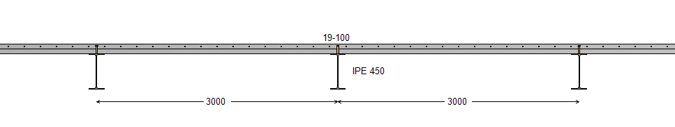
Figure 2 : Transversal view

Parameters
All parameters are the same as in Case C01, with the additional parameters:

Lateral restraint of the profile:
No lateral restraints in the span
Restraint by the steel profiled sheeting:
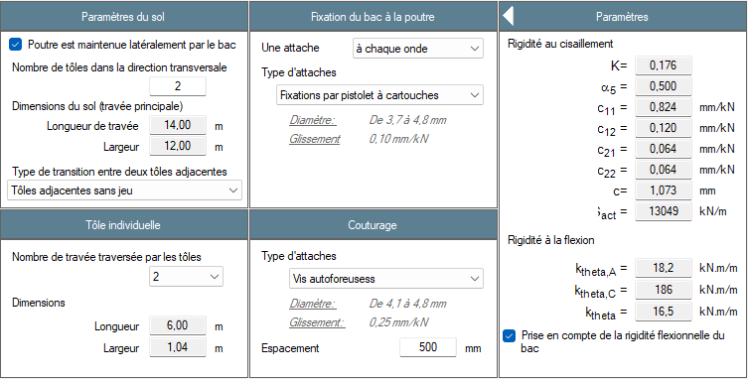

Definition of loads:
G1: self-weight only
live load QC: surface load 0,5 kN/m²
distributed load : 3 kN/m on the 3 m at the center of the span

Combination of loads:
ULS: 1,35 G1 + 1,5 QC

Verification of results
Case C02 Results: Analysis | Reference | ABCPMX | Dev.
Shear force : $V(G_{1})=$ (kN) | 50.8 | 50.8
Bending moment : $M(G_{1})=$ (kN.m) | 178 | 178
Shear force : $V(Q_{c})=$ (kN) | 15 | 15
Bending moment : $M(Q_{c})=$ (kN.m) | 64.8 | 64.9
Shear force : $V_{Ed}=$ (kN) | 91 | 91
Bending moment : $M_{Ed}=$ (kN.m) | 337 | 337

Case C02 Results: ULS during construction stage | Reference | ABCPMX | Dev.
Critical moment to lateral torsional buckling (without flexural bending of deck accounted for) : $M_{cr}$ (kN.m) | 2 260 | 2 304 | -1.91%
Critical moment to lateral torsional buckling (with flexural bending of deck accounted for) : $M_{cr}$ (kN.m) | 3 237 | 3 299 | -1.88%
Resistance to lateral torsional buckling (with flexural bending of deck accounted for) : $Γ_{LT}=$ | 0.77 | 0.77

CASE C03: Single span composite beam with partial encasement (construction phase)

Description
This test is based on the paper in the Construction Métallique review n°2023-3. It deals with a single span composite beam with a composite slab and partial encasement during its construction phase.
The values from the paper are used as references. Because the calculation method of the software is more accurate, some values of the review may not match perfectly.
It correspond to the construction phase of the case C04.
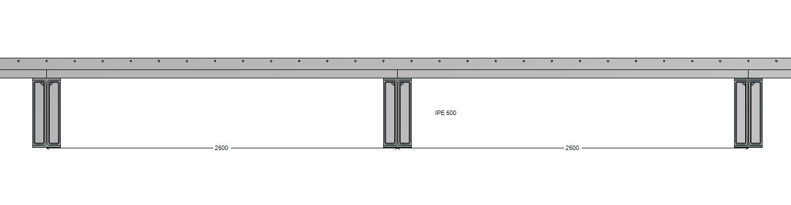
Figure 3 : Transversal view

Parameters
Definition of the beam:
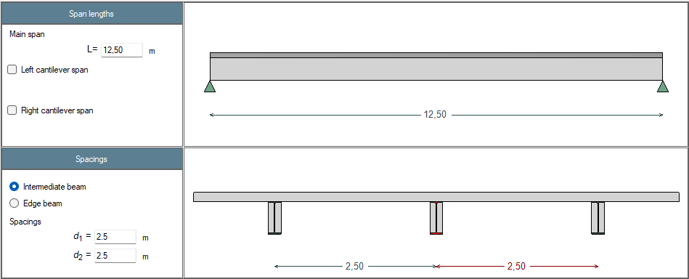

Definition of the slab:
Composite slab
Total depth: $t_{d}=140 mm$
Perpendicular ribs
Continuous ribs with un-continuous deck
Steel profiled sheeting: Cofraplus 60, thickness 1 mm
Prepunched sheeting
Unpropped beam during construction

Definition of the profile:
Hot rolled profile
Profile: IPE A 500
Steel grade: S355 M/ML

Definition of the concrete:
Normal concrete
Concrete class: C25/30
Density: $ρ_{c}=2500 {kg/m}^{3}$

Definition of the partial encasement:
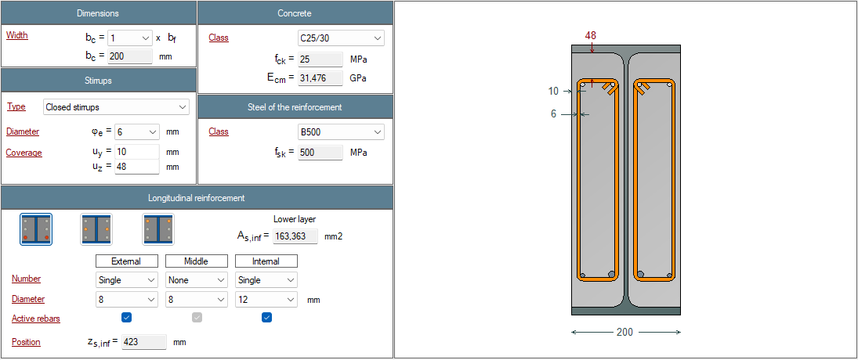

Lateral restraint of the profile:
No lateral restraints in the span
No restraint by the steel profiled sheeting

Definition of loads:
G1: self-weight only
live load QC: distributed load: 1,86 kN/m on the full length
distributed load : 1,05 kN/m on the 3 m at the centre of the span

Combination of loads:
ULS: 1,35 G1 + 1,5 QC

Verification of results
Case C03 Results: Steel profile | Reference | ABCPMX | Dev.
Cross-sectional area : $A$ = (cm²) | 101 | 101.1
Shear area : $A_{v}$ = (cm²) | 50.4 | 50.4
Second moment of area (y-y axis) : $I_{y}$ = (cm⁴) | 42 930 | 42 933
Second moment of area (z-z axis) : $I_{z}$ = (cm⁴) | 1 949 | 1 936 | 0.18%
Elastic section modulus about y-y axis : $W_{el,y}$ = (cm³) | 1 728 | 1 728
Elastic section modulus about z-z axis : $W_{el,z}$ = (cm³) | 193,9 | 193.6 | 0.18%
Plastic section modulus about y-y axis : $W_{pl,y}$ = (cm³) | 1 946 | 1 946
Plastic section modulus about z-z axis : $W_{pl,z}$ = (cm³) | 301.6 | 298.3 | 1.15%
Torsional moment : $I_{t}$ = (cm⁴) | 64.18 | 64.28 | -0.16%
Warping moment : $I_{w}$ = (cm⁶) | 1 125 000 | 1 125 230
Mass by length unit : $m_{lin}$ = (kg/ml) | 79,4 | 79,4
Mass : $m$ = (kg) | 994 | 992 | 0.16%
Total paint surface : $S$ = (cm²) | 217 643 | 217 643
Paint surface (without upper face) : $S$ = (cm²) | 192 643 | 192 643
Section factor : $M$ = (m⁻¹) | 172.0 | 172.2 | -0.14%
Section factor (without upper face) : $M$ = (m⁻¹) | 152.2 | 152.4 | -0.13%
Nominal yield strength : $f_{y}$ = (MPa) | 355 | 355
Axial resistance : $N_{t,Rd}$ = (kN) | 3 595 | 3 589 | 0.15%
Shear resistance : $V_{pl,Rd}$ = (kN) | 1 036 | 1 033 | 0.32%
Plastic resistance to bending : $M_{pl,Rd}$ = (kN.m) | 692 | 691 | 0.16%
Elastic resistance to bending : $M_{el,Rd}$ = (kN.m) | 614 | 613 | 0.24%
Section class for pure bending : | 1 | 1
Section class for pure compression : | 4 | 4
Shear buckling resistance : $h_{w}/t_{w}$ = | 50.7 | 50.7
Shear buckling resistance : $124ε$ = | 101 | 101
Verification of web buckling required? | No | No

Case C03 Results: Partial encasement | Reference | ABCPMX | Dev.
Notional size (EN 1992-1-1 Annex B) : $h_{\text{0}}=$ (mm) | 191 | 191
Char. value of the compression strength : $f_{\text{ck}}=$ (MPa) | 25 | 25
Mean value of compression strength : $f_{\text{cm}}=$ (MPa) | 33 | 33
Mean tensile strength : $f_{\text{ctm}}=$ (MPa) | 2.56 | 2.56
Mean secant modulus of elasticity : $E_{\text{cm}}=$ (MPa) | 31 476 | 31 476

Case C03 Results: Slab | Reference | ABCPMX | Dev.
Notional size (EN 1992-1-1 Annex B) : $h_{\text{0}}=$ (mm) | 210 | 210
Char. value of the compression strength : $f_{\text{ck}}=$ (MPa) | 25 | 25
Mean value of compression strength : $f_{\text{cm}}=$ (MPa) | 33 | 33
Mean tensile strength : $f_{\text{ctm}}=$ (MPa) | 2.56 | 2.56
Mean secant modulus of elasticity : $E_{\text{cm}}=$ (MPa) | 31 476 | 31 476
Sec. moment of area per unit of width : $I_{\text{pu}}=$ (cm⁴/m) | 60.08 | 60.08

Case C03 Results: Section properties at mid-span | Reference | ABCPMX | Dev.
Modular ratio : $n_{enrobage}(G_{1})=$ | 23.7 | 23.7
Modular ratio : $n_{enrobage}(Q_{c})=$ | 6.67 | 6.67
Second moment of area (y-y axis) : $I_{el,y}(n=6.67)$ (cm⁴) | 53 002 | 52 921 | 0.15%
Second moment of area (y-y axis) : $I_{el,y}\left(n=23.7\right)$ (cm⁴) | 47 200 | 47 128 | -0.15%
Second moment of area (y-y axis) : $I_{el,y}\left(n=24.7\right)$ (cm⁴) | 47 083 | 47 005 | -0.17%
Elastic neutral axis : $z_{el,y}(n=6.67)$ (mm) | 205 | 205
Elastic neutral axis : $z_{el,y}(n=23.7)$ (mm) | 235 | 235
Elastic neutral axis : $z_{el,y}(n=24.7)$ (mm) | 236 | 236
Plastic resistance to bending moment : $M_{pl,Rd}$ (kN.m) | 777 | 775 | 0.26%

Case C03 Results: Analysis | Reference | ABCPMX | Dev.
Shear force : $V(G_{1})=$ (kN) | 60.5 | 60.5
Bending moment : $M(G_{1})=$ (kN.m) | 189 | 189
Shear force : $V(Q_{c})=$ (kN) | 13.3 | 13.3
Bending moment : $M(Q_{c})=$ (kN.m) | 45.3 | 45.4 | -0.22%

Case C03 results: ULS | Reference | ABCPMX | Dev.
Resistance to bending moment : $Γ_{M}=$ | 0.42 | 0.42
Resistance to shear force : $Γ_{V}=$ | 0.10 | 0.10
Resistance to MV interaction : $Γ_{MV}=$ | 0.42 | 0.42
Critical moment to lateral torsional buckling : $M_{cr}$ (kN.m) | 903 | 914 | -1.20%
Resistance to lateral torsional buckling : $Γ_{LT}=$ | 0.66 | 0.63 | 4.76%

Case C03 Results: SLS | Reference | ABCPMX | Dev.
Deflection : $δ(G_{1})$ (mm) | 31.0 | 31.1 | -0.32%
Deflection : $δ(Q_{c})$ (mm) | 6.5 | 6.5
Deflection : $δ\left(SLS\right)$ (mm) | 37.5 | 37.6 | -0.27%

CASE C04: Single span composite beam with partial encasement (composite phase)

Description
This test is based on the paper in the Construction Métallique review n°2023-4. It deals with a single span composite beam with a composite slab and partial encasement during its final phase in composite stage.
The values from the paper are used as references. Because the calculation method of the software is more accurate, some values of the review may not match perfectly.
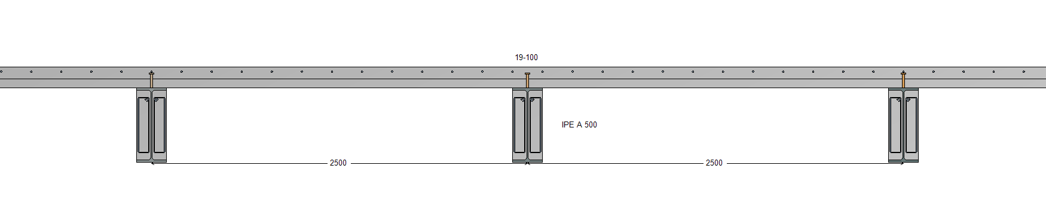
Figure 4 : Transversal view

Parameters
All parameters are the same as in Case 3, with the following specific parameters:

Definition of the connection:
Studs: 19x100
Two studs in each rib
Unpropped beam during construction

Definition of loads:
G1: self-weight only
G2: surface load 1,0 kN/m²
live load Q1: surface load 2,5 kN/m²

Combination of loads:
ULS: 1,35 (G1+G2) + 1,5 Q1
SLS: (G1+G2) + Q1

Design parameters:
Standard: Eurocodes first generation
Design: According to the class of cross-section
Relative humidity: 50 %
Shrinkage deformation: 325 x 10⁻⁶
Age of concrete: $t_{0}=28 d$ for G2
t = 50 x 365 d

Verification of results
Case C04 Results: Steel profile | Reference | ABCPMX | Dev.
Cross-sectional area : $A$ = (cm²) | 101 | 101.1
Shear area : $A_{v}$ = (cm²) | 50.4 | 50.4
Second moment of area (y-y axis) : $I_{y}$ = (cm⁴) | 42 930 | 42 933
Second moment of area (z-z axis) : $I_{z}$ = (cm⁴) | 1 949 | 1 936 | 0.18%
Elastic section modulus (y-y axis) : $W_{el,y}$ = (cm³) | 1 728 | 1 728
Elastic section modulus (z-z axis) : $W_{el,z}$ = (cm³) | 193,9 | 193.6 | 0.18%
Plastic section modulus (y-y axis) : $W_{pl,y}$ = (cm³) | 1 946 | 1 946
Plastic section modulus (z-z axis) : $W_{pl,z}$ = (cm³) | 301.6 | 298.3 | 1.15%
Torsional constant : $I_{t}$ = (cm⁴) | 64.18 | 64.28 | -0.16%
Warping constant : $I_{w}$ = (cm⁶) | 1 125 000 | 1 125 230
Mass by length unit : $m_{lin}$ = (kg/ml) | 79,4 | 79,4
Mass : $m$ = (kg) | 994 | 992 | 0.16%
Total paint surface : $S$ = (cm²) | 217 643 | 217 643
Paint surface (without upper face) : $S$ = (cm²) | 192 643 | 192 643
Section factor : $M$ = (m⁻¹) | 172.0 | 172.2 | -0.14%
Section factor (without upper face) : $M$ = (m⁻¹) | 152.2 | 152.4 | -0.13%
Nominal yield strength : $f_{y}$ = (MPa) | 355 | 355
Axial resistance : $N_{t,Rd}$ = (kN) | 3 595 | 3 589 | 0.15%
Shear resistance : $V_{pl,Rd}$ = (kN) | 1 036 | 1 033 | 0.32%
Plastic resistance to bending : $M_{pl,Rd}$ = (kN.m) | 692 | 691 | 0.16%
Elastic resistance to bending : $M_{el,Rd}$ = (kN.m) | 614 | 613 | 0.24%
Section class for pure bending : | 1 | 1
Section class for pure compression : | 4 | 4
Shear buckling resistance : $h_{w}/t_{w}$ = | 50.7 | 50.7
Shear buckling resistance : $124ε$ = | 101 | 101
Verification of web buckling required? | No | No

Case C04 Results: Partial encasement | Reference | ABCPMX | Dev.
Notional size (EN 1992-1-1 Annex B) : $h_{\text{0}}=$ (mm) | 191 | 191
Char. value of the compression strength : $f_{\text{ck}}=$ (MPa) | 25 | 25
Mean value of compression strength : $f_{\text{cm}}=$ (MPa) | 33 | 33
Mean tensile strength : $f_{\text{ctm}}=$ (MPa) | 2.56 | 2.56
Mean secant modulus of elasticity : $E_{\text{cm}}=$ (MPa) | 31 476 | 31 476

Case C04 Results: Slab | Reference | ABCPMX | Dev.
Notional size (EN 1992-1-1 Annex B) : $h_{\text{0}}=$ (mm) | 164 | 164
Char. value of the compression strength : $f_{\text{ck}}=$ (MPa) | 25 | 25
Mean value of compression strength : $f_{\text{cm}}=$ (MPa) | 33 | 33
Mean tensile strength : $f_{\text{ctm}}=$ (MPa) | 2.56 | 2.56
Mean secant modulus of elasticity : $E_{\text{cm}}=$ (MPa) | 31 476 | 31 476
Sec. moment of area per unit of width : $I_{\text{pu}}=$ (cm⁴/m) | 60.08 | 60.08
Shear resistance of studs : $P_{Rd}=$ (kN) | 37.4 | 37.4
Reduction factor : $k_{t}$ = | 0.50 | 0.50

Case C04 Results: Section properties at mid-span | Reference | ABCPMX | Dev.
Effective width of the slab : $b_{eff}=$ (m) | 2.50 | 2.50
Modular ratio : $n_{slab}(G_{1})=$ | $$-$$ | $$-$$
Modular ratio : $n_{encasement}(G_{1})=$ | 23.7 | 23.7
Modular ratio : $n_{slab}(G_{2})=$ | 26.6 | 26.6
Modular ratio : $n_{encasement}(G_{2})=$ | 23.7 | 23.7
Modular ratio : $n_{slab}(Q_{1})=$ | 6.67 | 6.67
Modular ratio : $n_{encasement}\left(Q_{1}\right)=$ | 6.67 | 6.67
Modular ratio : $n_{slab}(Q_{c})=$ | $$∞$$ | $$∞$$
Modular ratio : $n_{encasement}\left(Q_{c}\right)=$ | 6.67 | 6.67
Modular ratio : $n_{slab}\left(SHC\right)=$ | 25.2 | 25.2
Modular ratio : $n_{slab}\left(SHC\right)=$ | 24.7 | 24.7
Moment of inertia about y-y axis : $I_{el,y}(G_{1})$ (cm⁴) | 47 237 | 47 128 | 0.23%
Moment of inertia about y-y axis : $I_{el,y}\left(G_{2}\right)$ (cm⁴) | 99 895 | 99 778 | 0.12%
Moment of inertia about y-y axis : $I_{el,y}(Q_{1})$ (cm⁴) | 142 875 | 142 812 | 0.14%
Moment of inertia about y-y axis : $I_{el,y}(Q_{c})$ (cm⁴) | 53 094 | 52 921 | 0.33%
Moment of inertia about y-y axis : $I_{el,y}(SHC)$ (cm⁴) | 101 577 | 101 471 | 0.10 %
Elastic neutral axis : $z_{el,y}(G_{1})$ (mm) | -235 | -235 | 0.00%
Elastic neutral axis : $z_{el,y}(G_{2})$ (mm) | -102.4 | -102 | 0.39%
Elastic neutral axis : $z_{el,y}(Q_{1})$ (mm) | 9.38 | 9.51 | -1.37%
Elastic neutral axis : $z_{el,y}(Q_{c})$ (mm) | -205 | -205 | 0.00%
Elastic neutral axis : $z_{el,y}(SHC)$ (mm) | -98.1 | -97.9 | 0.20%
Plastic resistance to bending moment : $M_{pl,Rd}$ (kN.m) | 1 190 | 1 243 | +4,4%

Case C04 Results: Analysis | Reference | ABCPMX | Dev.
Shear force : $V(G_{1})=$ (kN) | 60.5 | 60.5
Bending moment : $M(G_{1})=$ (kN.m) | 189 | 189
Shear force : $V(G_{2})=$ (kN) | 15.6 | 15.6
Bending moment : $M(G_{2})=$ (kN.m) | 48.8 | 48.8
Shear force : $V(Q_{1})=$ (kN) | 39.1 | 39.1
Bending moment : $M(Q_{1})=$ (kN.m) | 122 | 122
Shear force : $V(Q_{c})=$ (kN) | 13.3 | 13.3
Bending moment : $M(Q_{c})=$ (kN.m) | 45.3 | 45.4 | -0.22%
Shear force : $V(SHC)=$ (kN) | 0 | 0
Bending moment : $M(SHC)=$ (kN.m) | 112.5 | 109.4
Shear force : $V_{Ed} (ULS01)=$ (kN) | 161 | 161
Bending moment : $M_{Ed} (ULS01)=$ (kN.m) | 504 | 504
Shear force : $V_{Ed,const} (ULSC01)=$ (kN) | 102 | 102
Bending moment : $M_{Ed,const} (ULSC01)=$ (kN.m) | 323 | 323

Case C04 Results: ULS at final stage | Reference | ABCPMX | Dev.
Resistance to bending moment : $Γ_{M}=$ | 0.42 | 0.426
Resistance to shear force : $Γ_{V}=$ | 0.16 | 0.156
Resistance to MV interaction : $Γ_{MV}=$ | 0.42 | 0.426
Degree of shear connection : $η=$ | 0.78 | 0.773
Minimum degree of connection : $η_{min}=$ | 0.63 | 0.625
Longitudinal shear force : $τ_{Ed}=$ (MPa) | 2.20 | 2.14 | 2.80%
Min. compression strut inclination angle : $θ_{f,min}=$ (°) | 27 | 27
Resistance of the compression strut : $Γ_{sf} =$ | 0.61 | 0.59 | 3.39%
Area of reinf. by length unit : $A_{sf}/s_{f} =$ (cm²/m) | 2.12 | 2.05 | 3.41%

Case C04 Results: ULS at construction stage | Reference | ABCPMX | Dev.
Resistance to bending moment : $Γ_{M}=$ | 0.42 | 0.42
Resistance to shear force : $Γ_{V}=$ | 0.10 | 0.10
Resistance to MV interaction : $Γ_{MV}=$ | 0.42 | 0.42
Critical moment to lateral torsional buckling : $M_{cr}$ (kN.m) | 903 | 914 | -1.20%
Resistance to lateral torsional buckling : $Γ_{LT}=$ | 0.66 | 0.63 | 4.76%

Case C04 Results: SLS assuming full connection | Reference | ABCPMX | Dev.
Deflection : $δ(G_{1})$ (mm) | 31.1 | 31.1
Deflection : $δ\left(G_{2}\right)$ (mm) | 3.79 | 3.79
Deflection : $δ(Q_{1})$ (mm) | 6.62 | 6.64
Deflection : $δ(Q_{c})$ (mm) | 6.5 | 6.5
Deflection : $δ\left(SHC\right)$ (mm) | 10.3 | 10.1 | 1.98%
Deflection : $δ\left(SLS\right)$ (mm) | 51.8 | 51.6 | 0.58%
Eigen frequency : $f\left(G+0.2Q_{1}\right)$ (Hz) | 4.6 | 4.7 | -2.54%

CASE C05: Composite beam cantilever span

Description
Test a composite beam with a cantilever span at the left end.

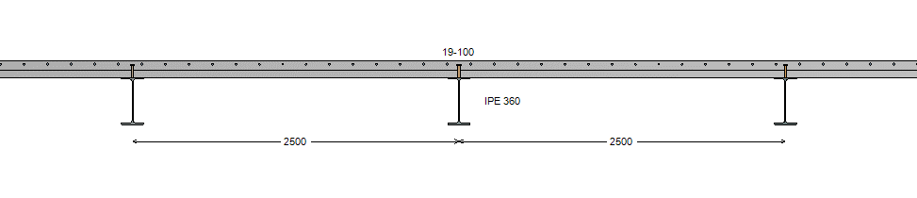
Figure 5 : Transversal view

Parameters
Definition of the beam:
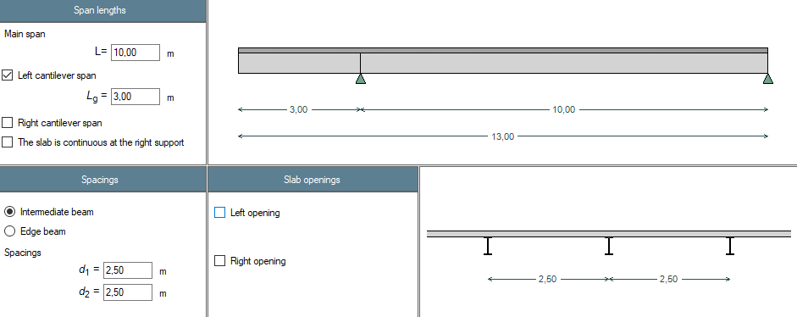

Definition of the slab:
Composite slab
Total depth: $t_{d}=130 mm$
Perpendicular ribs
Steel profiled sheeting: Cofraplus 60, thickness 0,75 mm
Prepunched sheeting

Definition of the profile:
Hot rolled profile
Profile: IPE 360
Steel grade: S355 JR

Definition of the concrete:
Normal concrete
Concrete class: C35/45
Density: $ρ_{c}=2500 {kg/m}^{3}$

Definition of the connection:
Studs: 19x100
Two studs in each rib
Unpropped beam during construction

Definition of loads:
G1: self-weight only
G2: surface load 2 kN/m² on each span
live load Q1: surface load 16 kN/m² on each span

Combination of loads:
ULS: 1,35 (G1+G2) + 1,5 Q1
SLS: (G1+G2) + Q1

Design parameters:
Standard: Eurocodes first generation
Design: According to the class of cross-section
Shear resistance: $η=1,2$
Relative humidity: 50 %
Shrinkage deformation: 325 x 10⁻⁶
Age of concrete: $t_{0}=28 d$ for G2
t = 50 x 365 d

Verification of results
Case C05 Results: Steel profile | Reference | ABCPMX | Dev.
Cross-sectional area : $A$ = (cm²) | 72,7 | 72,7
Shear area : $A_{v}$ = (cm²) | 35,14 | 35,14
Second moment of area (y-y axis) : $I_{y}$ = (cm⁴) | 16 270 | 16 266
Second moment of area (z-z axis) : $I_{z}$ = (cm⁴) | 1 043 | 1 041
Elastic section modulus (y-y axis) : $W_{el,y}$ = (cm³) | 903,6 | 903,6
Elastic section modulus (z-z axis) : $W_{el,z}$ = (cm³) | 122,8 | 122,5
Plastic section modulus (y-y axis) : $W_{pl,y}$ = (cm³) | 1 019 | 1 019
Plastic section modulus (z-z axis) : $W_{pl,z}$ = (cm³) | 191,1 | 188,9
Torsional constant : $I_{t}$ = (cm⁴) | 37,32 | 37,44
Warping constant : $I_{w}$ = (cm⁶) | 313 600 | 316 580
Mass by length unit : $m_{lin}$ = (kg/ml) | 57,1 | 57,1
Nominal yield strenght : $f_{y}$ = (MPa) | 355 | 355
Tensile resistance : $N_{t,Rd}$ = (kN) | 2 581,9 | 2582
Shear resistance : $V_{pl,Rd}$ = (kN) | 720,2 | 720
Plastic moment resistant : $M_{pl,Rd}$ = (kN.m) | 361,7 | 362
Elastic moment resistant : $M_{el,Rd}$ = (kN.m) | 320,8 | 321
Section class for bending : | 1 | 1
Section class for compression : | 4 | 4
Shear buckling resistance : $h_{w}/t_{w}$ = | 41,83 | 41,8
Shear buckling resistance : $72ε/η$ = | 48,82 | 48,8
Verification of web buckling required? | No | No

Case C05 Results: slab | Reference | ABCPMX | Dev.
Notional size (EN 1992-1-1 Annex B) : $h_{\text{0}}=$ (mm) | 144 | 144
Char. value of the compression strength : $f_{\text{ck}}=$ (MPa) | 35 | 35
Mean value of compression strength : $f_{\text{cm}}=$ (MPa) | 43 | 43
Mean tensile strength : $f_{\text{ctm}}=$ (MPa) |  | 3,21
Mean secant modulus of elasticity : $E_{\text{cm}}=$ (MPa) | 34 080 | 34 077
Sec. moment of area per unit of width : $I_{\text{pu}}=$ (cm⁴/m) | 44.37 | 44,37
Shear resistance of the connector : $P_{Rd}=$ (kN) | 41,13 | 41,13
Reduction factor : $k_{t}$ = | 0,50 | 0,50

Case C05 Results: Analysis for load cases | Reference | ABCPMX | Dev.
Shear force at support A – central span : $V(G_{1})=$ (kN) | 35,88 | 35,88
Shear force at support B – central span : $V(G_{1})=$ (kN) | 29,96 | 29,96
Bending moment at support A : $M(G_{1})=$ (kN.m) | -29,6 | -29,6
Max. bending moment in central span : $M(G_{1})=$ (kN.m) | 68,14 | 68,14
Shear force at support A – central span : $V(G_{2})=$ (kN) | 27,25 | 27,25
Shear force at support B – central span : $V(G_{2})=$ (kN) | 22,75 | 22,75
Bending moment at support A : $M(G_{2})=$ (kN.m) | -22,50 | -22,50
Max. bending moment in central span : $M(G_{2})=$ (kN.m) | 51,75 | 51,75
Shear force at support A – central span : $V(Q_{1}\#1)=$ (kN) | 218 | 218
Shear force at support B – central span : $V(Q_{1}\#1)=$ (kN) | 182 | 182
Bending moment at support A : $M(Q_{1}\#1)=$ (kN.m) | -180 | -180
Max. bending moment in central span : $M(Q_{1}\#1)=$ (kN.m) | 414 | 414
Shear force at support A – central span : $V(Q_{1}\#2)=$ (kN) | 200 | 200
Shear force at support B – central span : $V(Q_{1}\#2)=$ (kN) | 200 | 200
Bending moment at support A : $M(Q_{1}\#2)=$ (kN.m) | 0 | 0
Max. bending moment in central span : $M(Q_{1}\#2)=$ (kN.m) | 500 | 500
Shear force at support A – central span : $V(Q_{1}\#3)=$ (kN) | 18,0 | 18,0
Shear force at support B – central span : $V(Q_{1}\#3)=$ (kN) | 18,0 | 18,0
Bending moment at support A : $M(Q_{1}\#3)=$ (kN.m) | -180,0 | -180,0
Max. bending moment in central span : $M(Q_{1}\#3)=$ (kN.m) | 0 | 0

Case C05 Results: Analysis for ULS combination | Reference | ABCPMX | Dev.
Shear force at support A – central span : $V({ULS}_{1}\#1)=$ (kN) | 412,23 | 412,2
Shear force at support B – central span : $V({ULS}_{1}\#1)=$ (kN) | 344,15 | 344,2
Bending moment at support A : $M({ULS}_{1}\#1)=$ (kN.m) | -340,37 | -340,4
Max. bending moment in central span : $M({ULS}_{1}\#1)=$ (kN.m) | 782,86 | 782,9
Shear force at support A – central span : $V({ULS}_{1}\#2)=$ (kN) | 385,23 | 385,2
Shear force at support B – central span : $V({ULS}_{1}\#2)=$ (kN) | 371,15 | 371,2
Bending moment at support A : $M({ULS}_{1}\#2)=$ (kN.m) | -70,37 | -70,37
Max. bending moment in central span : $M({ULS}_{1}\#2)=$ (kN.m) | 910,29 | 910,6
Shear force at support A – central span : $V({ULS}_{1}\#3)=$ (kN) | 112,23 | 112,2
Shear force at support B – central span : $V({ULS}_{1}\#3)=$ (kN) | 44,15 | 44,15
Bending moment at support A : $M({ULS}_{1}\#3)=$ (kN.m) | -340,37 | -340,4
Max. bending moment in central span : $M({ULS}_{1}\#3)=$ (kN.m) | 62,09 | 62,33

Case C05 Results: ULS at final stage | Reference | ABCPMX | Dev.
Resistance to bending moment : $Γ_{M}=$ | 1,575 | 1,575
Resistance to shear force : $Γ_{V}=$ | 0,572 | 0,572
Resistance to MV interaction : $Γ_{MV}=$ | 1,575 | 1,575
Degree of shear connection ($M>0$) : $η=$ | 0,431 | 0,428
Minimum degree of connection ($M>0$) : $η_{min}=$ | 0,505 | 0,505
Degree of shear connection ($M<0$) : $η=$ | 1 | 1,03
Minimum degree of connection ($M<0$) : $η_{min}=$ | 1 | 1

Case C05 Results: Transverse reinforcements in the main span | Reference | ABCPMX | Dev.
Longitudinal shear force : $τ_{Ed}=$ (MPa) | 2,66 | 2,66
Min. compression strut inclination angle : $θ_{f,min}=$ (°) | 36 | 36
Resistance of the compression strut : $Γ_{sf} =$ | 0,464 | 0,46
Area of reinf. by length unit : $A_{sf}/s_{f} =$ (cm²/m) | 3,20 | 3,20

CASE C05b: Composite beam cantilever span

Description
Test a composite beam with a cantilever span at the right end.

Figure 6 : Transversal view

Parameters
The case C05b is identical to Case C05, except that the cantilever is defined on the right end of the beam.

Verification of results
Case C05b Results: Analysis for load cases | Reference | ABCPMX | Dev.
Shear force at support A – central span : $V(G_{1})=$ (kN) | 29,96 | 29,96
Shear force at support B – central span : $V(G_{1})=$ (kN) | 35,88 | 35,88
Bending moment at support B : $M(G_{1})=$ (kN.m) | -29,6 | -29,6
Max. bending moment in central span : $M(G_{1})=$ (kN.m) | 68,14 | 68,14
Shear force at support A – central span : $V(G_{2})=$ (kN) | 22,75 | 22,75
Shear force at support B – central span : $V(G_{2})=$ (kN) | 27,25 | 27,25
Bending moment at support B : $M(G_{2})=$ (kN.m) | -22,50 | -22,50
Max. bending moment in central span : $M(G_{2})=$ (kN.m) | 51,75 | 51,75
Shear force at support A – central span : $V(Q_{1}\#1)=$ (kN) | 182 | 182
Shear force at support B – central span : $V(Q_{1}\#1)=$ (kN) | 218 | 218
Bending moment at support B : $M(Q_{1}\#1)=$ (kN.m) | -180 | -180
Max. bending moment in central span : $M(Q_{1}\#1)=$ (kN.m) | 414 | 414
Shear force at support A – central span : $V(Q_{1}\#2)=$ (kN) | 200 | 200
Shear force at support B – central span : $V(Q_{1}\#2)=$ (kN) | 200 | 200
Bending moment at support B : $M(Q_{1}\#2)=$ (kN.m) | 0 | 0
Max. bending moment in central span : $M(Q_{1}\#2)=$ (kN.m) | 500 | 500
Shear force at support A – central span : $V(Q_{1}\#3)=$ (kN) | 18,0 | 18,0
Shear force at support B – central span : $V(Q_{1}\#3)=$ (kN) | 18,0 | 18,0
Bending moment at support B : $M(Q_{1}\#3)=$ (kN.m) | -180,0 | -180,0
Max. bending moment in central span : $M(Q_{1}\#3)=$ (kN.m) | 0 | 0

Case C05b Results: Analysis for ULS combination | Reference | ABCPMX | Dev.
Shear force at support A – central span : $V({ULS}_{1}\#1)=$ (kN) | 344,15 | 344,2
Shear force at support B – central span : $V({ULS}_{1}\#1)=$ (kN) | 412,23 | 412,2
Bending moment at support B : $M({ULS}_{1}\#1)=$ (kN.m) | -340,37 | -340,4
Max. bending moment in central span : $M({ULS}_{1}\#1)=$ (kN.m) | 782,86 | 782,9
Shear force at support A – central span : $V({ULS}_{1}\#2)=$ (kN) | 371,15 | 371,2
Shear force at support B – central span : $V({ULS}_{1}\#2)=$ (kN) | 385,23 | 385,2
Bending moment at support B : $M({ULS}_{1}\#2)=$ (kN.m) | -70,37 | -70,37
Max. bending moment in central span : $M({ULS}_{1}\#2)=$ (kN.m) | 910,29 | 910,6
Shear force at support A – central span : $V({ULS}_{1}\#3)=$ (kN) | 44,15 | 44,15
Shear force at support B – central span : $V({ULS}_{1}\#3)=$ (kN) | 112,23 | 112,2
Bending moment at support B : $M({ULS}_{1}\#3)=$ (kN.m) | -340,37 | -340,4
Max. bending moment in central span : $M({ULS}_{1}\#3)=$ (kN.m) | 62,09 | 62,33

Case C05b Results: ULS at final stage | Reference | ABCPMX | Dev.
Resistance to bending moment : $Γ_{M}=$ | 1,575 | 1,575
Resistance to shear force : $Γ_{V}=$ | 0,572 | 0,572
Resistance to MV interaction : $Γ_{MV}=$ | 1,575 | 1,575
Degree of shear connection ($M>0$) : $η=$ | 0,431 | 0,428
Minimum degree of connection ($M>0$) : $η_{min}=$ | 0,505 | 0,505
Degree of shear connection ($M<0$) : $η=$ | 1 | 1,03
Minimum degree of connection ($M<0$) : $η_{min}=$ | 1 | 1

Case C05b Results: Transverse reinforcements | Reference | ABCPMX | Dev.
Longitudinal shear force : $τ_{Ed}=$ (MPa) | 2,66 | 2,66
Min. compression strut inclination angle : $θ_{f,min}=$ (°) | 36 | 36
Resistance of the compression strut : $Γ_{sf} =$ | 0,464 | 0,46
Area of reinf. by length unit : $A_{sf}/s_{f} =$ (cm²/m) | 3,20 | 3,20

Tests cases – Steel beams

CASE S01: Steel beam with 2 cantilever spans

Description
This test deals with a steel beam with both left and right cantilevers.
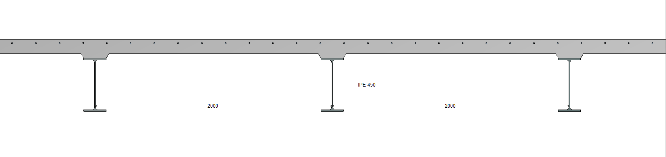
Figure 7 : Transversal view

Parameters
Definition of the beam:
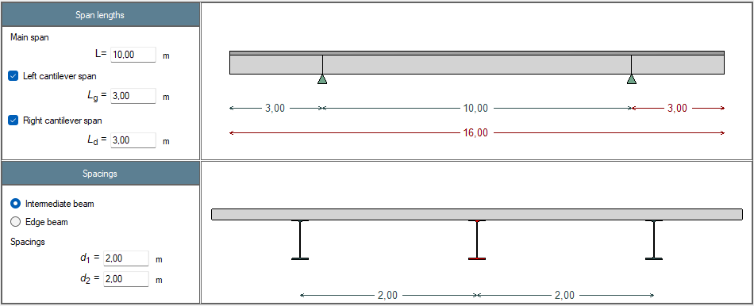

Definition of the profile:
Hot rolled profile
Profile: IPE 450
Steel grade: S355 M/ML

Definition of the slab:
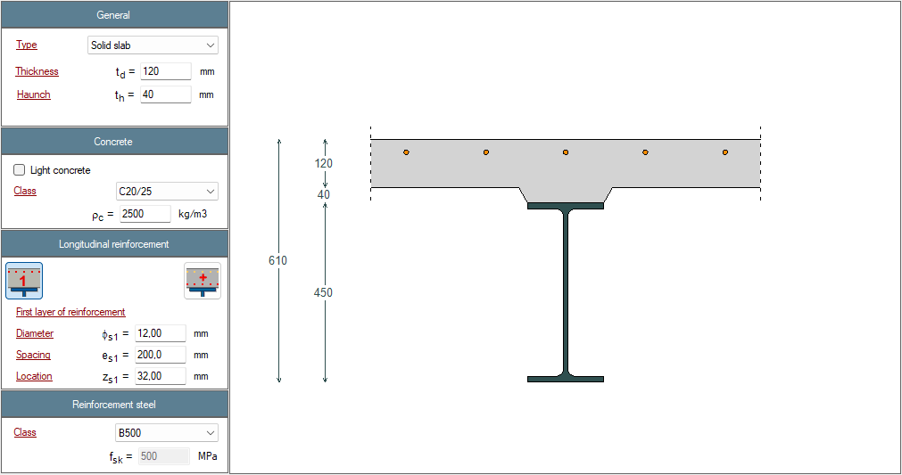

Lateral restraint of the profile:
One lateral restraints at mid-span of the central span, for both flanges

Definition of loads:
G1: self-weight only
live load Q1: left cantilever span: distributed load from 0 (left end) to 1 kN/m (right end)
central span: distributed load from 1 (left end) to 3 kN/m (right end)
right cantilever span: distributed load from 3 (left end) to 5 kN/m (right end)

Definition of loads:
$$η=1,2$$

Verification of results
Case S01 Results: steel profile | Reference | ABCPMX | Dev.
Cross-sectional area : $A$ = (cm²) | 98.8 | 98.8
Shear area : $A_{v}$ = (cm²) | 50.8 | 50.8
Second moment of area (y-y axis) : $I_{y}$ = (cm⁴) | 33 740 | 33 743 | 0.01%
Second moment of area (z-z axis) : $I_{z}$ = (cm⁴) | 1 676 | 1 672 | 0.24%
Elastic section modulus (y-y axis) : $W_{el,y}$ = (cm³) | 1 500 | 1 500
Elastic section modulus (z-z axis) : $W_{el,z}$ = (cm³) | 176 | 176
Plastic section modulus (y-y axis) : $W_{pl,y}$ = (cm³) | 1 702 | 1 702
Plastic section modulus (z-z axis) : $W_{pl,z}$ = (cm³) | 276 | 272.8 | 1.17%
Torsional constant : $I_{t}$ = (cm⁴) | 66.66 | 66.75 | 0.13%
Warping constant : $I_{w}$ = (cm⁶) | 780 739 | 791 005 | 1.30%
Mass by length unit : $m_{lin}$ = (kg/ml) | 77.7 | 77.6 | 0.13%
Mass : $m$ = (kg) | 1 243 | 1 241 | 0.16%
Total paint surface : $S$ = (m²) | 25,68 | 25,68
Paint surface (without upper face) : $S$ = (m²) | 22,64 | 22,64
Section factor : $M$ = (m⁻¹) | 162.4 | 162.4
Section factor (without upper face) : $M$ = (m⁻¹) | 143.2 | 143.2
Nominal yield strength : $f_{y}$ = (MPa) | 355 | 355
Axial resistance : $N_{t,Rd}$ = (kN) | 3 508 | 3 508
Shear resistance : $V_{pl,Rd}$ = (kN) | 1 402 | 1 402
Plastic moment resistant : $M_{pl,Rd}$ = (kN.m) | 604 | 604
Elastic moment resistant : $M_{el,Rd}$ = (kN.m) | 532 | 532
Section class for bending : | 1 | 1
Section class for compression : | 4 | 4
Shear buckling resistance : $h_{w}/t_{w}$ = | 44,8 | 44,8
Shear buckling resistance : $72ε/η$ = | 48.8 | 48.8
Verification of web buckling required? | No | No

Case S01 Results: Analysis | Reference | ABCPMX | Dev.
Shear force : $V(G_{1})=$ (kN) | 34.4 | 34.2 | 0.58%
Bending moment : $M(G_{1})=$ (kN.m) | 55.1/-31 | 54.8/-30.8 | 0.73%/0.65%
Shear force : $V(Q_{1}\#1)=$ (kN) | 13.5 | 13.5
Bending moment : $M(Q_{1}\#1)=$ (kN.m) | 14.7/-19.5 | 14.7/-19.5
Shear force : $V(Q_{1}\#2)=$ (kN) | 11.7 | 11.7
Bending moment : $M(Q_{1}\#2)=$ (kN.m) | 25.2 | 25.2
Shear force : $V(Q_{1}\#3)=$ (kN) | 12 | 12
Bending moment : $M(Q_{1}\#3)=$ (kN.m) | -19.5 | -19.5
Shear force : $V_{Ed,ULS\#1}=$ (kN) | 66.7 | 66.4 | 0.45%
Bending moment : $M_{Ed,ULS\#1}=$ (kN.m) | 96.2/-71.1 | 95.8/-70.8 | 0.52%/0.42%
Shear force : $V_{Ed,ULS\#2}=$ (kN) | 64.0 | 63.7 | 0.47%
Bending moment : $M_{Ed,ULS\#2}=$ (kN.m) | 112/-41.8 | 111/-41.6 | 0.90%/0.48%
Shear force : $V_{Ed,ULS\#3}=$ (kN) | 49.2 | 48.9 | 0.61%
Bending moment : $M_{Ed,SLS\#3}=$ (kN.m) | 59.0/-71.1 | 58.6/-70.8 | 0.85%/0.42%

Case S01 Results: ULS in the central span | Reference | ABCPMX | Dev.
Resistance to bending moment : $Γ_{M,ULS\#1}=$ | 0.16 | 0.159
Resistance to shear force : $Γ_{V,ULS\#1}=$ | 0.06 | 0.064
Resistance to MV interaction : $Γ_{MV,ULS\#1}=$ | 0.16 | 0.159
Critical moment to lateral torsional buckling : $M_{cr,max,ULS\#1}$ (kN.m) | 521.97 | 523.4 | -0.27%
Resistance to lateral torsional buckling : $Γ_{LT,ULS\#1}=$ | 0.29 | 0.288
Resistance to bending moment : $Γ_{M,ULS\#2}=$ | 0.19 | 0.185
Resistance to shear force : $Γ_{V,ULS\#2}=$ | 0.06 | 0.061
Resistance to MV interaction : $Γ_{MV,ULS\#2}=$ | 0.19 | 0.185
Critical moment to lateral torsional buckling : $M_{cr,max,ULS\#2}$ (kN.m) | 546.2 | 545.3 | 0.53%
Resistance to lateral torsional buckling : $Γ_{LT,ULS\#2}=$ | 0.33 | 0.327
Resistance to bending moment : $Γ_{M,ULS\#3}=$ | 0.12 | 0.117
Resistance to shear force : $Γ_{V,ULS\#3}=$ | 0.05 | 0.047
Resistance to MV interaction : $Γ_{MV,ULS\#3}=$ | 0.12 | 0.117
Critical moment to lateral torsional buckling : $M_{cr,max,ULS\#3}$ (kN.m) | 496.6 | 497.1 | -0.10%
Resistance to lateral torsional buckling : $Γ_{LT,ULS\#3}=$ | 0.22 | 0.220

Case S01 Results: sls | Reference | ABCPMX | Dev.
Deflection central span : $δ(G_{1})$ (mm) | 7.19 | 7.14
Deflection central span : $δ(Q_{1}\#1)$ (mm) | 1.83 | 1.83 | 0.00%
Deflection central span : $δ(Q_{1}\#2)$ (mm) | 3.68 | 3.68 | 0.00%
Deflection right span : $δ(Q_{1}\#3)$ (mm) | 3.50 | 3.50
Deflection central span : $δ(SLS\#1)$ (mm) | 9.01 | 8.96
Deflection central span : $δ(SLS\#2)$ (mm) | 10.9 | 10.8
Deflection central span : $δ(SLS\#3)$ (mm) | 5.34 | 5.30

CASE S02: Steel beam with welded profile

Description
This test deals with a steel beam with welded profile (double symmetric).

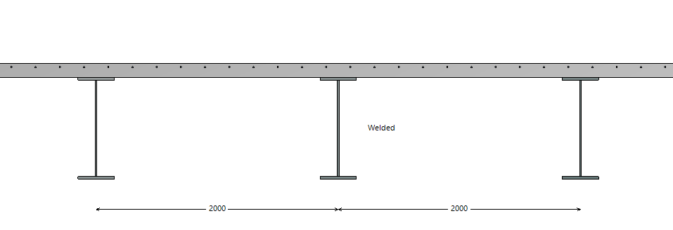
Figure 8 : Transversal view

Parameters
Definition of the beam:
Single span
Span length: 15 m

Definition of the profile:
Welded profile
Upper flange: 300x20
Web: 800x12
Lower flange: 300x20
Steel grade: S355 JR

Definition of loads:
G1: distributed load: 12 kN/m
live load Q1: distributed load: 20 kN/m
live load Q2: concentrated load: 15 kN at mid span

Lateral restraints:
2 lateral restraints of both flange at 1/3 and 2/3 of the span length

Partial factors and national factors:
$$γ_{G}=1,4$$
$$γ_{Q}=1,6$$
$$γ_{M0}=1,05$$
$$γ_{M1}=1,1$$
$$γ_{M2}=1,25$$
$$ψ_{0}=0,7$$
$$η=1,2$$

Combination of loads:
ULS-01: $γ_{G} G+γ_{Q} Q_{1}+γ_{Q} ψ_{0} Q_{2}$
ULS-02: $γ_{G} G+γ_{Q} ψ_{0} Q_{1}+γ_{Q} Q_{2}$
SLS: $G+Q_{1}+Q_{2}$

Design parameters:
Standard: Eurocodes first generation

Verification of results
Case S02 Results: steel profile | Reference | ABCPMX | Dev.
Cross-sectional area : $A$ = (cm²) | 216 | 216
Shear area : $A_{v}$ = (cm²) | 115,2 | 115,2
Second moment of area (y-y axis) : $I_{y}$ = (cm⁴) | 252 960 | 252 960
Second moment of area (z-z axis) : $I_{z}$ = (cm⁴) | 9012 | 9012
Elastic section modulus (y-y axis) : $W_{el,y}$ = (cm³) | 6023 | 6023
Mass by length unit : $m_{lin}$ = (kg/ml) | 170 | 170
Mass : $m$ = (kg) | 2543 | 2543
Total paint surface : $S$ = (cm²) | 42,84 | 42,84
Paint surface (without upper face) : $S$ = (cm²) | 38,34 | 38,34
Nominal yield strength flanges : $f_{y}$ = (MPa) | 345 | 345
Nominal yield strength web : $f_{y}$ = (MPa) | 355 | 355
Axial resistance : $N_{t,Rd}$ = (kN) | 7189 | 7189
Shear resistance : $V_{pl,Rd}$ = (kN) | 2249 | 2249
Plastic bending resistance (y-y axis) : $M_{pl,Rd}$ = (kNm) | 2266 | 2266
Elastic bending resistance (y-y axis) : $M_{el,Rd}$ = (kNm) | 1979 | 1979
Section class for bending : | 2 | 2
Section class for compression : |  | 4
Shear buckling resistance : $h_{w}/t_{w}$ = | 66,67 | 66,67
Shear buckling resistance : $72ε/η$ = | 48,82 | 48,82
Verification of web buckling required? | Yes | Yes

Case S02 Results: Analysis | Reference | ABCPMX | Dev.
Shear force : $V(G_{1})=$ (kN) | 90 | 90
Bending moment : $M(G_{1})=$ (kN.m) | 337,5 | 337,5
Shear force : $V(Q_{1})=$ (kN) | 150 | 150
Bending moment : $M(Q_{1})=$ (kN.m) | 562.5 | 562.5
Shear force : $V(Q_{2})=$ (kN) | 7,5 | 7,5
Bending moment : $M(Q_{2})=$ (kN.m) | 56,3 | 56,3
Shear force : $V_{Ed,ULS-1}=$ (kN) | 374,4 | 374,4
Bending moment : $M_{Ed,ULS-1}=$ (kN.m) | 1435,5 | 1435,5
Shear force : $V_{Ed,ULS-2}=$ (kN) | 306 | 306
Bending moment : $M_{Ed,ULS-2}=$ (kN.m) | 1192,5 | 1192,5

Case S02 Results: ULS | Reference | ABCPMX | Dev.
Resistance to bending moment : $Γ_{M}$ | 0,634 | 0,634
Resistance to shear force : $Γ_{V}$ | 0,166 | 0,166
Resistance to shear buckling : $Γ_{Vb}$ | 0,239 | 0,239
Resistance to MV interaction : $Γ_{MV}$ | - | -
Critical moment to lateral torsional buckling : $M_{cr,max,ULS-1}$ (kN.m) | 4163 | 4163
Resistance to lateral torsional buckling : $Γ_{LT}=$ | 1,09 | 1,09
Minimum design size of welds: $a_{w}$ (mm) | 0,75 | 0,75

Case S02 Results: sls | Reference | ABCPMX | Dev.
Deflection : $δ(G)$ (mm) | 14,9 | 14,9
Deflection : $δ(Q_{1})$ (mm) | 24,8 | 24,8
Deflection : $δ(Q_{2})$ (mm) | 1,99 | 1,98
Deflection : $δ(SLS)$ (mm) | 41,7 | 41,7
Eigen frequency : $f(G+0,2 Q_{1})$ (Hz) | 3,98 | 3,98
Modal mass: (kg) | 12 232 | 12 232

CASE S02b: Steel beam with welded profile

Description
This test deals with a steel beam with welded profile (double symmetric). An elastic design is triggered by the class 3 section
Figure 9 : Transversal view

Parameters
All parameters are the same as in Case S02, with the following modifications:
Definition of the profile:
Welded profile
Upper flange: 300x20
Web: 800x12
Lower flange: 300x20
Steel grade: S460 JR

Definition of loads:
G1: distributed load: 12 kN/m
live load Q1: distributed load: 20 kN/m
live load Q2: concentrated load: 30 kN at mid span

Verification of results
Case S02b Results: steel profile | Reference | ABCPMX | Dev.
Cross-sectional area : $A$ = (cm²) | 216 | 216
Shear area : $A_{v}$ = (cm²) | 115,2 | 115,2
Second moment of area (y-y axis) : $I_{y}$ = (cm⁴) | 252 960 | 252 960
Second moment of area (z-z axis) : $I_{z}$ = (cm⁴) | 9012 | 9012
Elastic section modulus (y-y axis) : $W_{el,y}$ = (cm³) | 6023 | 6023
Mass by length unit : $m_{lin}$ = (kg/ml) | 170 | 170
Mass : $m$ = (kg) | 2543 | 2543
Total paint surface : $S$ = (cm²) | 42,84 | 42,84
Paint surface (without upper face) : $S$ = (cm²) | 38,34 | 38,34
Nominal yield strength flanges : $f_{y}$ = (MPa) | 440 | 440
Nominal yield strength web : $f_{y}$ = (MPa) | 460 | 460
Axial resistance : $N_{t,Rd}$ = (kN) | 9234 | 9234
Shear resistance : $V_{pl,Rd}$ = (kN) | 2914 | 2914
Plastic bending resistance (y-y axis) : $M_{el,Rd}$ = (kNm) | 2524 | 2524
Elastic bending resistance (y-y axis) : $M_{pl,Rd}$ = (kNm) | 2903 | 2903
Section class for bending : | 3 | 3
Shear buckling resistance : $h_{w}/t_{w}$ = | 66,67 | 66,67
Shear buckling resistance : $72ε/η$ = | 42,89 | 42,89
Verification of web buckling required? | Yes | Yes

Case S02b Results: Analysis | Reference | ABCPMX | Dev.
Shear force : $V(G_{1})=$ (kN) | 90 | 90
Bending moment : $M(G_{1})=$ (kN.m) | 337,5 | 337,5
Shear force : $V(Q_{1})=$ (kN) | 150 | 150
Bending moment : $M(Q_{1})=$ (kN.m) | 562.5 | 562.5
Shear force : $V(Q_{2})=$ (kN) | 15 | 15
Bending moment : $M(Q_{2})=$ (kN.m) | 112,5 | 112,5
Shear force : $V_{Ed,ULS-1}=$ (kN) | 382,8 | 382,8
Bending moment : $M_{Ed,ULS-1}=$ (kN.m) | 1498,5 | 1498,5
Shear force : $V_{Ed,ULS-2}=$ (kN) | 318 | 318
Bending moment : $M_{Ed,ULS-2}=$ (kN.m) | 1282,5 | 1282,5

Case S01 Results: ULS | Reference | ABCPMX | Dev.
Resistance to bending moment : $Γ_{M}$ | 0,594 | 0,594
Resistance to shear force : $Γ_{V}$ | 0,131 | 0,131
Resistance to shear buckling : $Γ_{Vb}$ | 0,215 | 0,215
Resistance to MV interaction : $Γ_{MV}$ | - | -
Critical moment to lateral torsional buckling : $M_{cr,max,ULS-1}$ (kN.m) | 4189 | 4189
Resistance to lateral torsional buckling : $Γ_{LT}=$ | 1,07 | 1,07
Minimum design size of welds: $a_{w}$ (mm) | 0,75 | 0,73

Case S02 Results: sls | Reference | ABCPMX | Dev.
Deflection : $δ(G)$ (mm) | 14,9 | 14,9
Deflection : $δ(Q_{1})$ (mm) | 24,8 | 24,8
Deflection : $δ(Q_{2})$ (mm) | 3,97 | 3,97
Deflection : $δ(SLS)$ (mm) | 43,7 | 43,7
Eigen frequency : $f(G+0,2 Q_{1})$ (Hz) | 3,98 | 3,98
Modal mass: (kg) | 12 232 | 12 232

CASE S03: Steel beam with welded profile and MV interaction

Description
This test deals with a steel beam with welded profile and a MV interaction.
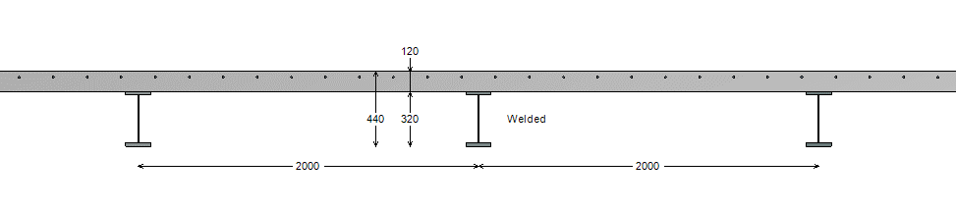
Figure 10 : Transversal view

Parameters
Definition of the beam:
Single span with a cantilever span on the left
Span length: 9 m
Cantilever length: 2,5 m

Definition of the profile:
Welded profile
Upper flange: 150x18
Web: 280x6
Lower flange: 150x22
Steel grade: S275 JR

Definition of the slab:
solid slab: $t_{d}=120 mm$

Definition of loads:
live load Q1: distributed load on the cantilever span: 75 kN/m

Lateral restraints:
2 lateral restraints of both flange at 1/3 and 2/3 of the span length

Partial factors and national factors:
$$γ_{M0}=1,0$$
$$γ_{M1}=1,0$$
$$γ_{M2}=1,25$$
$$η=1,0$$

Combination of loads:
ULS-01: $Q_{1}$
SLS: $Q_{1}$

Design parameters:
Standard: Eurocodes first generation

Verification of results
Case S03 Results: steel profile | Reference | ABCPMX | Dev.
Cross-sectional area : $A$ = (cm²) | 76,80 | 76,80
Shear area : $A_{v}$ = (cm²) | 16,8 | 16,8
Second moment of area (y-y axis) : $I_{y}$ = (cm⁴) | 14 517 | 14 517
Location of the elastic neutral axis: $z_{y,ENA}$ = (mm) | 170,5 | 170,5
Second moment of area (z-z axis) : $I_{z}$ = (cm⁴) | 1 125 | 1 126
Torsion constant : $I_{t}$ = (cm⁴) | 78,91 | 78,91
Warping factor : $I_{w}$ = (cm⁶) | 250593 | 250594
Mass by length unit : $m_{lin}$ = (kg/ml) | 60 | 60
Mass : $m$ = (kg) | 693 | 693
Total paint surface : $S$ = (cm²) | 14,12 | 14,12
Paint surface (without upper face) : $S$ = (cm²) | 12,40 | 12,40
Nominal yield strength flanges : $f_{y}$ = (MPa) | 275 | 275
Nominal yield strength web : $f_{y}$ = (MPa) | 275 | 275
Axial resistance : $N_{t,Rd}$ = (kN) | 2 112 | 2 112
Shear resistance : $V_{pl,Rd}$ = (kN) | 267,0 | 267
Plastic bending resistance (y-y axis) : $M_{pl,Rd}$ = (kNm) | 276 | 276
Location of the plastic neutral axis: $z_{y,PNA}$ = (mm) | 208 | 208
Elastic bending resistance (y-y axis) : $M_{el,Rd}$ = (kNm) | 234 | 234
Section class for bending : | 1 | 1
Section class for compression : | 4 | 4
Shear buckling resistance : $h_{w}/t_{w}$ = | 46,67 | 46,7
Shear buckling resistance : $72ε/η$ = | 66,56 | 66,56
Verification of web buckling required? | No | No

Case S03 Results: Analysis | Reference | ABCPMX | Dev.
Shear force : $V(Q_{1})=$ (kN) | 187,5 | 187,5
Bending moment : $M(Q_{1})=$ (kN.m) | -234,4 | -234,4

Case S03 Results: ULS | Reference | ABCPMX | Dev.
Resistance to bending moment : $Γ_{M}$ | 0,850 | 0,850
Resistance to shear force : $Γ_{V}$ | 0,703 | 0,703
Resistance to shear buckling : $Γ_{Vb}$ | - | -
Resistance to MV interaction : $Γ_{MV}$ | 0,869 | 0,869
Critical moment to lateral torsional buckling : $M_{cr,max,ULS-1}$ (kN.m) | 632,5 | 642,8 | +1,6%
Resistance to lateral torsional buckling : $Γ_{LT}=$ | 1,27 | 1,26
Minimum design size of welds upper flange: $a_{w}$ (mm) | 1,40 | 1,40
Minimum design size of welds lower flange: $a_{w}$ (mm) | 1,47 | 1,47

Case S03 Results: sls | Reference | ABCPMX | Dev.
Deflection at the end of the cantilever : $δ(Q_{1})$ (mm) | 69,7 | 69,7
Deflection at mid span : $δ(Q_{1})$ (mm) | -39,9 | -39,9

CASE S03b: Steel beam with welded profile and MV interaction

Description
This test deals with a steel beam with welded profile and a MV interaction.
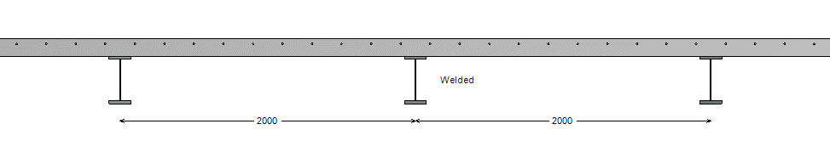
Figure 11 : Transversal view

Parameters
The case S03b is identical to Case S03, except that the cantilever is defined on the right end of the beam.

Verification of results
Case S03b Results: Analysis | Reference | ABCPMX | Dev.
Shear force : $V(Q_{1})=$ (kN) | 187,5 | 187,5
Bending moment : $M(Q_{1})=$ (kN.m) | -234,4 | -234,4

Case S03b Results: ULS | Reference | ABCPMX | Dev.
Resistance to bending moment : $Γ_{M}$ | 0,850 | 0,850
Resistance to shear force : $Γ_{V}$ | 0,703 | 0,703
Resistance to shear buckling : $Γ_{Vb}$ | - | -
Resistance to MV interaction : $Γ_{MV}$ | 0,869 | 0,869
Critical moment to lateral torsional buckling : $M_{cr,max,ULS-1}$ (kN.m) | 632,5 | 647,8 | +2,4%
Resistance to lateral torsional buckling : $Γ_{LT}=$ | 1,27 | 1,26
Minimum design size of welds upper flange: $a_{w}$ (mm) | 1,40 | 1,40
Minimum design size of welds lower flange: $a_{w}$ (mm) | 1,47 | 1,47

Case S03b Results: sls | Reference | ABCPMX | Dev.
Deflection at the end of the cantilever : $δ(Q_{1})$ (mm) | 69,7 | 69,7
Deflection at mid span : $δ(Q_{1})$ (mm) | -39,9 | -39,9

CASE S04: Steel beam with welded profile and interaction between bending and shear buckling

Description
This test deals with a steel beam with welded profile and a MV interaction.
Figure 12 : Transversal view

Parameters
Definition of the beam:
Single span with a cantilever span on the left
Span length: 9 m
Cantilever length: 2,5 m

Definition of the profile:
Welded profile
Upper flange: 150x18
Web: 280x5
Lower flange: 150x22
Steel grade: S460 EC3

Definition of loads:
live load Q1: distributed load on the cantilever span: 120 kN/m

Lateral restraints:
2 lateral restraints of both flange at 1/3 and 2/3 of the span length

Partial factors and national factors:
$$γ_{M0}=1,0$$
$$γ_{M1}=1,0$$
$$γ_{M2}=1,25$$
$$η=1,2$$

Combination of loads:
ULS-01: $Q_{1}$
SLS: $Q_{1}$

Design parameters:
Standard: Eurocodes first generation

Verification of results
Case S04 Results: steel profile | Reference | ABCPMX | Dev.
Cross-sectional area : $A$ = (cm²) | 74 | 74
Shear area : $A_{v}$ = (cm²) | 16,8 | 16,8
Second moment of area (y-y axis) : $I_{y}$ = (cm⁴) | 14 329 | 14 329
Location of the elastic neutral axis: $z_{y,ENA}$ = (mm) | 171,0 | 171
Second moment of area (z-z axis) : $I_{z}$ = (cm⁴) | 1 125,3 | 1 125
Mass by length unit : $m_{lin}$ = (kg/ml) | 58,1 | 58,1
Mass : $m$ = (kg) | 668 | 668
Total paint surface : $S$ = (cm²) | 14,15 | 14,15
Paint surface (without upper face) : $S$ = (cm²) | 12,42 | 12,42
Nominal yield strength flanges : $f_{y}$ = (MPa) | 460 | 460
Nominal yield strength web : $f_{y}$ = (MPa) | 460 | 460
Axial resistance : $N_{t,Rd}$ = (kN) | 3 404 | 3 404
Shear resistance : $V_{pl,Rd}$ = (kN) | 446,2 | 446,2
Plastic bending resistance (y-y axis) : $M_{pl,Rd}$ = (kNm) | 451 | 451
Location of the plastic neutral axis: $z_{y,PNA}$ = (mm) | 218 | 218
Elastic bending resistance (y-y axis) : $M_{el,Rd}$ = (kNm) | 386 | 386
Section class for bending : | 3
Section class for compression : | 4 | 4
Shear buckling resistance : $h_{w}/t_{w}$ = | 56,0 | 56,0
Shear buckling resistance : $72ε/η$ = | 42,9 | 42,9
Verification of web buckling required? | Yes | Yes

Case S04 Results: Analysis | Reference | ABCPMX | Dev.
Shear force : $V(Q_{1})=$ (kN) | 300 | 300
Bending moment : $M(Q_{1})=$ (kN.m) | -375 | -375

Case S04 Results: ULS | Reference | ABCPMX | Dev.
Resistance to bending moment : $Γ_{M}$ | 0,973 | 0,973
Resistance to shear force : $Γ_{V}$ | 0,672 | 0,672
Resistance to shear buckling : $Γ_{Vb}$ | 0,881 | 0,881
Resistance to MV interaction : $Γ_{MV}$ | 0,933 | 0,933

Case S04 Results: sls | Reference | ABCPMX | Dev.
Deflection at the end of the cantilever : $δ(Q_{1})$ (mm) | 112,9 | 112,9
Deflection at mid span : $δ(Q_{1})$ (mm) | -64,8 | -64,8

CASE S04b: Steel beam with welded profile and interaction between bending and shear buckling

Description
This test deals with a steel beam with welded profile and a MV interaction.
Figure 12 : Transversal view

Parameters
The case S03b is identical to Case S04, except that the cantilever is defined on the right end of the beam.

Verification of results

Case S04 Results: Analysis | Reference | ABCPMX | Dev.
Shear force : $V(Q_{1})=$ (kN) | 300 | 300
Bending moment : $M(Q_{1})=$ (kN.m) | -375 | -375

Case S04 Results: ULS | Reference | ABCPMX | Dev.
Resistance to bending moment : $Γ_{M}$ | 0,973 | 0,973
Resistance to shear force : $Γ_{V}$ | 0,672 | 0,672
Resistance to shear buckling : $Γ_{Vb}$ | 0,881 | 0,881
Resistance to MV interaction : $Γ_{MV}$ | 0,933 | 0,933

Case S04 Results: sls | Reference | ABCPMX | Dev.
Deflection at the end of the cantilever : $δ(Q_{1})$ (mm) | 112,9 | 112,9
Deflection at mid span : $δ(Q_{1})$ (mm) | -64,8 | -64,8

CASE 6: Simply supported composite beam with welded steel section

Description
This test deals with a simple welded steel beam. Because the calculation method of the software is more accurate, some values of the review may not match perfectly.
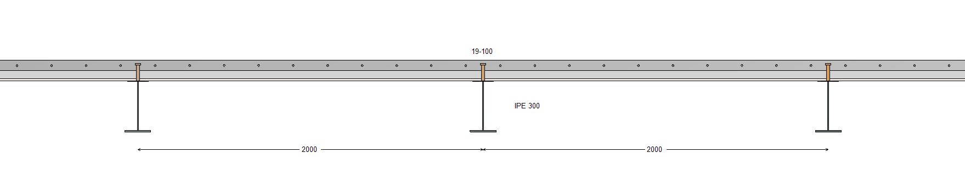
Figure 13 : Transversal view

Parameters
Definition of the beam:
Span length: 10 m
Intermediate beam
Spacing of adjacent beams: 2 m

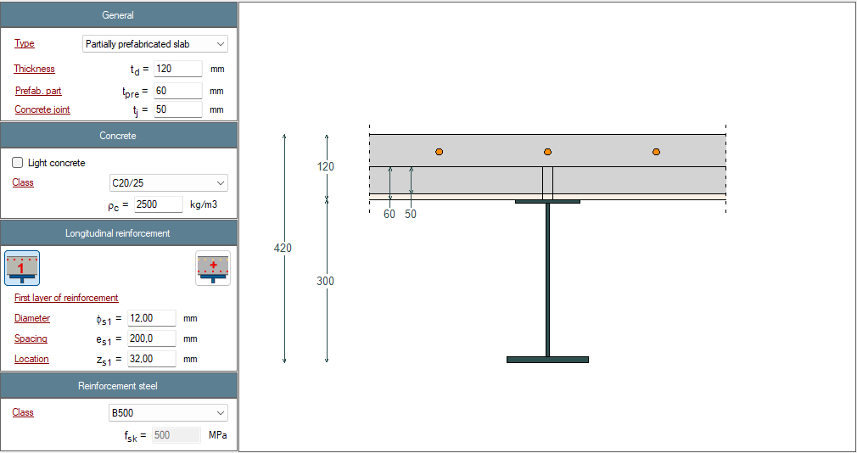
Figure 14 : Definition of the slab

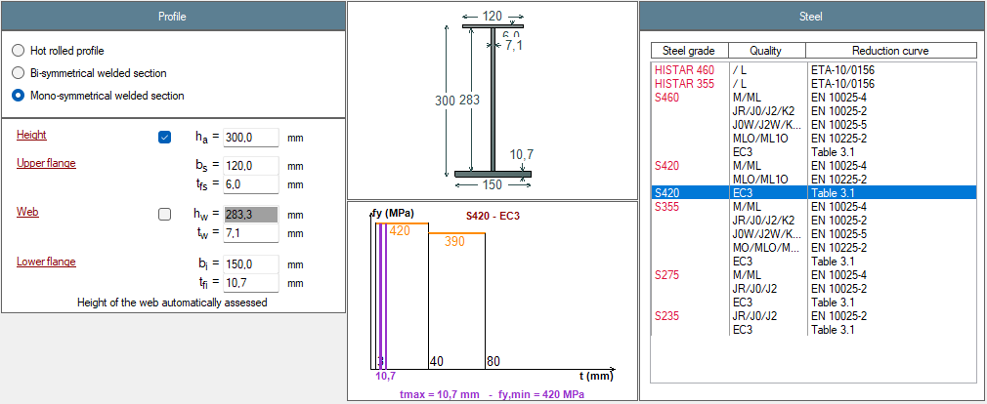
Figure 15 : Definition of the steel profile

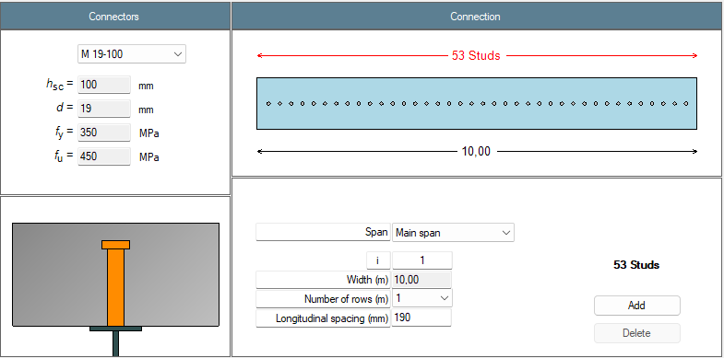
Figure 16 : Definition of the connection

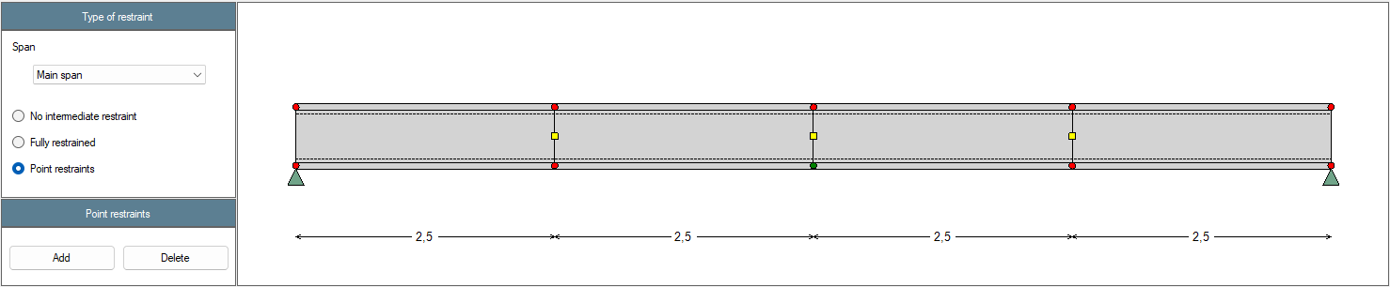
Figure 17 : Definition of the lateral restraints
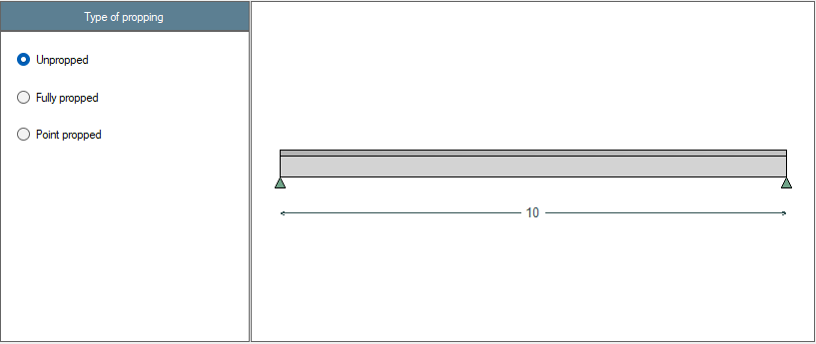
Figure 18 : Propping of the beam

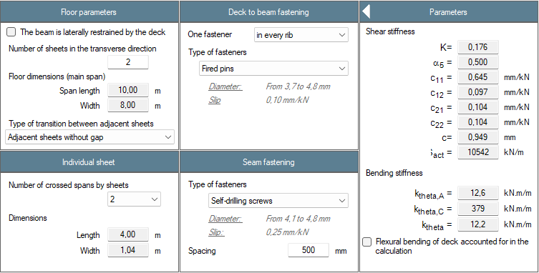
Figure 19 : Restraint of the beam by steel deck (construction phase only)

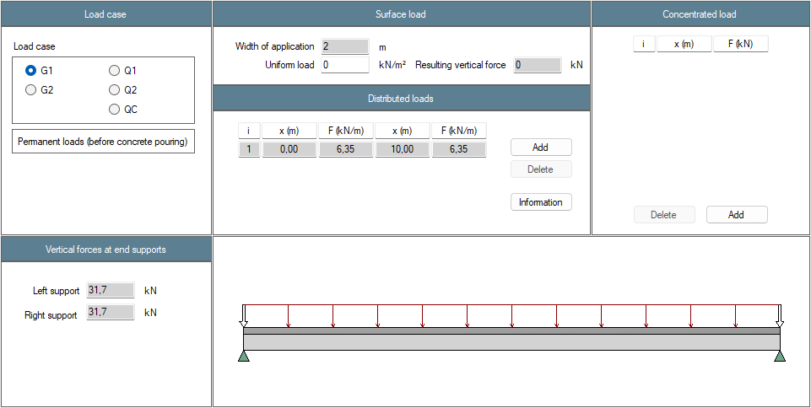
Figure 20 : Definition of the load cases – Permanent loads G1
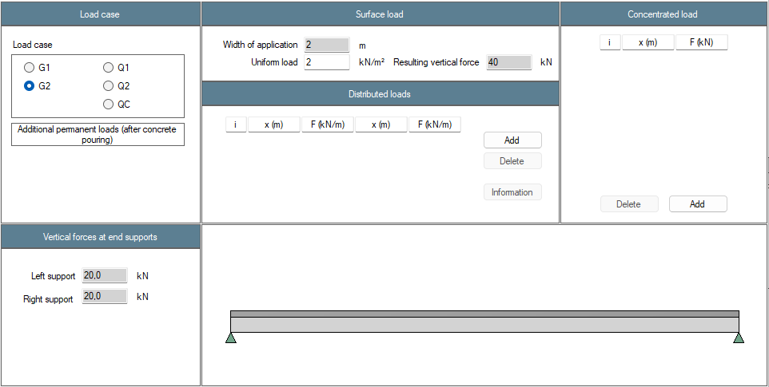
Figure 21 : Definition of the load cases – Additional permanent loads G2

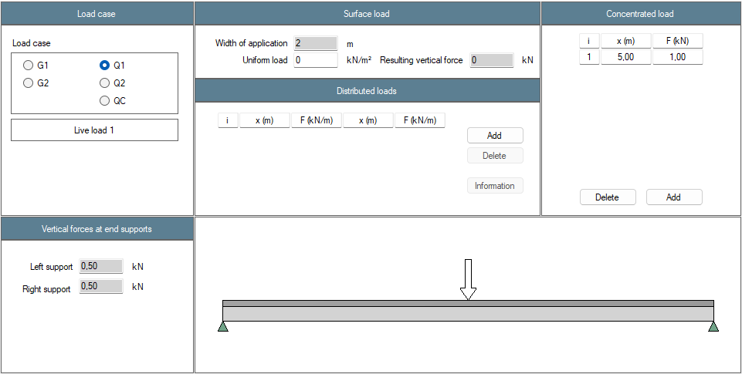
Figure 22 : Definition of the load cases – Live load 1 Q1

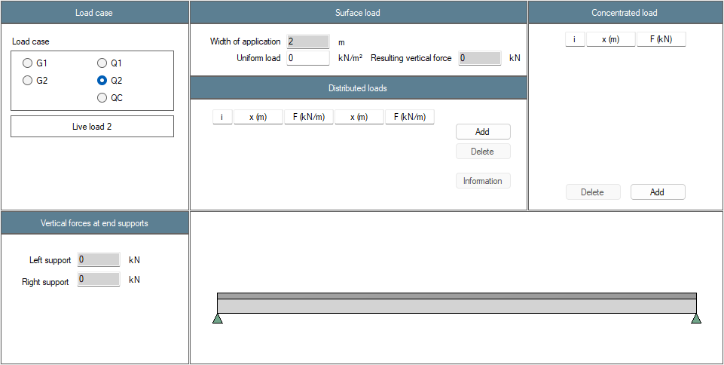
Figure 23 : Definition of the load cases – Live load 2 Q2

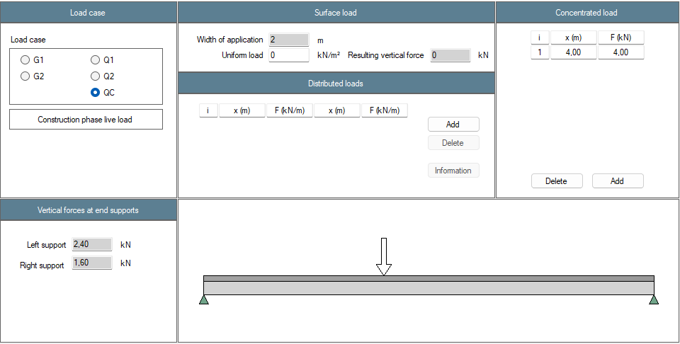
Figure 24 : Definition of the load cases – Construction phase live load QC

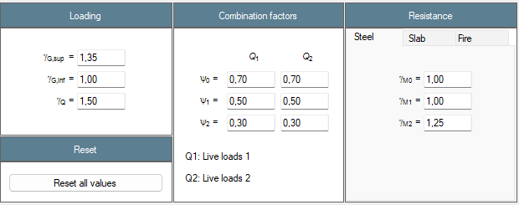
Figure 25 : Definition of national factors

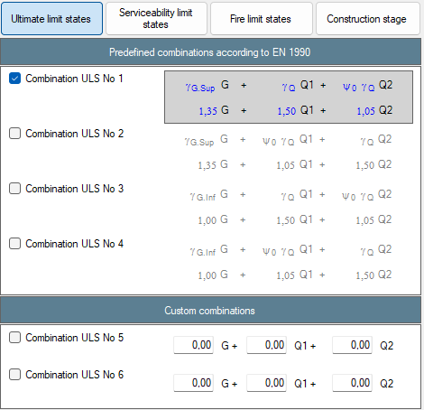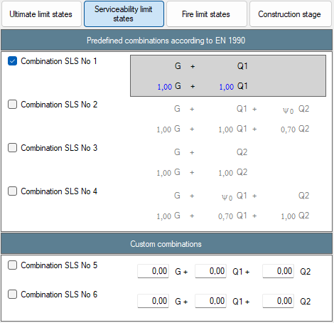
Figure 26 : Combinations – ULS and SLS
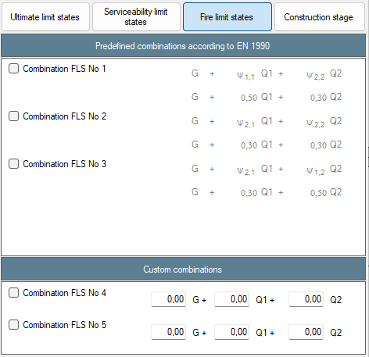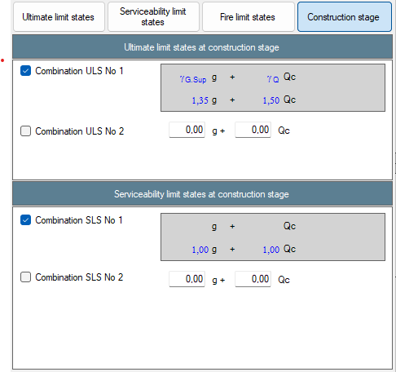
Figure 27 : Combinations – FLS and construction stage
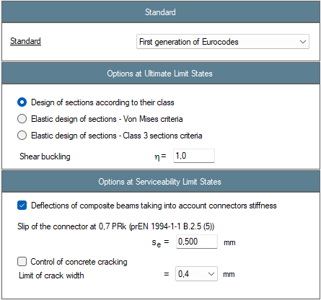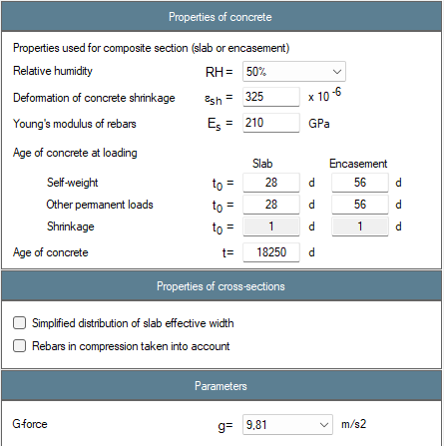
Figure 28 : Beam calculation options
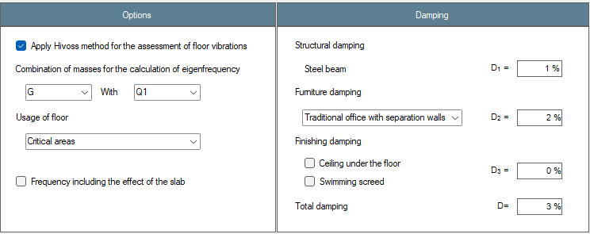
Figure 29 : Floor vibrations parameters

Results
Résultats | Reference | ABCPMX | Dev.
Cross-sectional area : $A$ = (cm²) | 43.4 | 43.4 | 0.00%
Shear area : $A_{v}$ = (cm²) | 20.1 | 20.1 | 0.00%
Moment of inertia about y-y axis : $I_{y}$ = (cm⁴) | 5 921 | 5 921 | 0.00%
Moment of inertia about z-z axis : $I_{z}$ = (cm⁴) | 388 | 388 | 0.00%
Elastic section modulus about y-y axis : $W_{el,y}$ = (cm³) | 332.6 | 332.6 | 0.00%
Elastic section modulus about z-z axis : $W_{el,z}$ = (cm³) | 51.8 | 51.8 | 0.00%
Plastic section modulus about y-y axis : $W_{pl,y}$ = (cm³) | 455.0 | 455.0 | 0.00%
Plastic section modulus about z-z axis : $W_{pl,z}$ = (cm³) | 84.2 | 85.4 | -0.24%
Torsional moment : $I_{t}$ = (cm⁴) | 10.29 | 10.34 | -0.48%
Warping moment : $I_{w}$ = (cm⁶) | 57 128 | 57 098 | -0.05%
Linear mass : $m_{lin}$ = (kg/ml) | 34.0 | 34.0 | 0.00%
Mass : $m$ = (kg) | 340.4 | 340.4 | 0.00%
Total paint surface : $S$ = (cm²) | 112 580 | 112 580 | 0.00%
Paint surface (without upper face) : $S$ = (cm²) | 100 580 | 100 580 | 0.00%
Massiveness : $M$ = (m⁻¹) | 259.6 | 259.6 | 0.00%
Massiveness (without upper face) : $M$ = (m⁻¹) | 231.9 | 231.9 | 0.00%
Nominal yield strenght : $f_{y,s}$ = (MPa) | 420 | 420 | 0.00%
Nominal yield strenght : $f_{y,w}$ = (MPa) | 420 | 420 | 0.00%
Nominal yield strenght : $f_{y,i}$ = (MPa) | 420 | 420 | 0.00%
Young’s modulus : $E$ = (MPa) | 210 000 | 210 000 | 0.00%
Density : $ρ$ = (kg/m³) | 7 850 | 7 850 | 0.00%
Tensile resistance : $N_{t,Rd}$ = (kN) | 1 821 | 1 821 | 0.00%
Shear resistance : $V_{pl,Rd}$ = (kN) | 488 | 488 | 0.00%
Plastic moment resistant : $M_{pl,Rd}$ = (kN.m) | 191 | 191 | 0.00%
Elastic moment resistant : $M_{el,Rd}$ = (kN.m) | 140 | 140 | 0.00%
Section class for bending : | 3 | 3 | 0.00%
Section class for compression : | 4 | 4 | 0.00%
Shear buckling resistance : $h_{w}/t_{w}$ = | 39.9 | 39.9 | 0.00%
Shear buckling resistance : $72ε/η$ = | 53.9 | 53.9 | 0.00%
Verification of web buckling necessary ? | No | No | Ok
Table 1: Steel profile
Résultats | Reference | ABCPMX | Dev.
Notional size (EN 1992-1-1 Annex B) : $h_{\text{0}}=$ (mm) | 124 | 124 | 0.00%
Char. value of the compression strenght : $f_{\text{ck}}=$ (MPa) | 20 | 20 | 0.00%
Mean value of compression strenght : $f_{\text{cm}}=$ (MPa) | 28 | 28 | 0.00%
Mean tensile strenght : $f_{\text{ctm}}=$ (MPa) | 2.21 | 2.21 | 0.00%
Mean secant modulus of elasticity : $E_{\text{cm}}=$ (MPa) | 29 962 | 29 962 | 0.00%
Shear resistance : $P_{Rd}=$ (kN) | 64.8 | 64.8 | 0.00%
Table 2: Slab
Résultats | Reference | ABCPMX | Dev.
Effective width of the slab : $b_{eff}=$ (m) | 2.0 | 2.0 | 0.00%
Modular ratio : $n_{slab}(G_{1})=$ | $$∞$$ | $$∞$$ | 0.00%
Modular ratio : $n_{slab}(G_{2})=$ | 30.8 | 30.8 | 0.00%
Modular ratio : $n_{slab}(Q_{1})=$ | 7.01 | 7.01 | 0.00%
Modular ratio : $n_{slab}(Q_{c})=$ | $$∞$$ | $$∞$$ | 0.00%
Modular ratio : $n_{slab}\left(SHC\right)=$ | 29.1 | 29.1 | 0.00%
Moment of inertia about y-y axis : $I_{el,y}(G_{1})$ (cm⁴) | 5 921 | 5 921 | 0.00%
Moment of inertia about y-y axis : $I_{el,y}\left(G_{2}\right)$ (cm⁴) | 22 644 | 22 581 | 0.28%
Moment of inertia about y-y axis : $I_{el,y}(Q_{1})$ (cm⁴) | 31 404 | 31 404 | 0.00%
Moment of inertia about y-y axis : $I_{el,y}(Q_{c})$ (cm⁴) | 5 921 | 5 921 | 0.00%
Moment of inertia about y-y axis : $I_{el,y}(SHC)$ (cm⁴) | 23 006 | 22 952 | 0.24%
Elastic neutral axis : $z_{el,y}(G_{1})$ (mm) | -178 | -178 | 0.00%
Elastic neutral axis : $z_{el,y}(G_{2})$ (mm) | -25.1 | -26.8 | -6.34%
Elastic neutral axis : $z_{el,y}(Q_{1})$ (mm) | 38.8 | 38.8 | 0.00%
Elastic neutral axis : $z_{el,y}(Q_{c})$ (mm) | -178 | -178 | 0.00%
Elastic neutral axis : $z_{el,y}(SHC)$ (mm) | -22.1 | -23.7 | -6.75%
Plastic resistance to bending moment : $M_{pl,Rd}$ (kN.m) | 470 | 470 | 0.00%
Including reduction factor : $β$ | 0.975 | 0.975 | 0.00%
Table 3: Section properties at mid-span
Résultats | Reference | ABCPMX | Dev.
Shear force : $V(G_{1})=$ (kN) | 31.1 | 31.1 | 0.00%
Bending moment : $M(G_{1})=$ (kN.m) | 77.7 | 77.7 | 0.00%
Shear force : $V(G_{2})=$ (kN) | 20 | 20 | 0.00%
Bending moment : $M(G_{2})=$ (kN.m) | 50 | 50 | 0.00%
Shear force : $V(Q_{1})=$ (kN) | 0.5 | 0.5 | 0.00%
Bending moment : $M(Q_{1})=$ (kN.m) | 2.5 | 2.5 | 0.00%
Shear force : $V(Q_{c})=$ (kN) | 2.4 | 2.4 | 0.00%
Bending moment : $M(Q_{c})=$ (kN.m) | 9.6 | 9.6 | 0.00%
Shear force : $V(SHC)=$ (kN) | 0 | 0 | 0.00%
Bending moment : $M(SHC)=$ (kN.m) | 49 | 45.7 | 7.22%
Shear force : $V_{Ed}=$ (kN) | 69.7 | 69.7 | 0.00%
Bending moment : $M_{Ed}=$ (kN.m) | 176.2 | 176.1 | 0.06%
Shear force : $V_{Ed,const}=$ (kN) | 45.6 | 46.5 | 0.00%
Bending moment : $M_{Ed,const}=$ (kN.m) | 117 | 117 | 0.00%
Table 4: Analysis

Résultats | Reference | ABCPMX | Dev.
Class of the composite section : | 3 | 3 | 0.00%
Resistance to bending moment : $Γ_{M}=$ | 0.91 | 0.90 | 1.11%
Resistance to shear force : $Γ_{V}=$ | 0.14 | 0.14 | 0.00%
Resistance to MV interaction : $Γ_{MV}=$ | 0.52 | 0.51 | 1.96%
Resistance of connection : $Γ_{connex}=$ | 0.22 | 0.23 | 4.35%
Web to upper flange welds design value : $a_{ws,calcul}=$ (mm) | 0.36 | 0.36 | 0.00%
Web to lower flange welds design value : $a_{wi,calcul}=$ (mm) | 0.39 | 0.39 | 0.00%
Longitudinal shear force (a-a) : $τ_{Ed,a-a}=$ (MPa) |  | 1.55
Min. compression strut inclination angle (a-a) : $θ_{f,min,a-a}=$ (°) |  | 27.0
Resistance of the compression strut (a-a) : $Γ_{sf,a-a} =$ |  | 0.52
Area of reinf. by length unit (a-a) : ${\left(A_{sf}/s_{f}\right)}_{a-a} =$ (cm²/m) |  | 2.00
Longitudinal shear force (d-d) : $τ_{Ed,d-d}=$ (MPa) |  | 1.11
Min. compression strut inclination angle (d-d) : $θ_{f,min,d-d}=$ (°) |  | 27.0
Resistance of the compression strut (d-d) : $Γ_{sf,d-d} =$ |  | 0.37
Area of reinf. by length unit (d-d) : ${\left(A_{sf}/s_{f}\right)}_{d-d} =$ (cm²/m) |  | 4.00
Table 5: ULS at final stage

Résultats | Reference | ABCPMX | Dev.
Class of the steel section : |  | 3
Resistance to bending moment : $Γ_{M}=$ |  | 0.75
Resistance to shear force : $Γ_{V}=$ |  | 0.09
Resistance to MV interaction : $Γ_{MV}=$ |  | 0.09
Critical moment to lateral torsional buckling : $M_{cr}$ (kN.m) |  | 146.5
Resistance to lateral torsional buckling : $Γ_{LT}=$ |  | 1.75
Web to upper flange welds design value : $a_{ws}=$ (mm) |  | 0.20
Web to lower flange welds design value : $a_{wi}=$ (mm) |  | 0.30
Table 6: ULS at construction stage

Résultats | Reference | ABCPMX | Dev.
Deflection : $δ(G_{1})$ (mm)
Deflection : $δ\left(G_{2}\right)$ (mm)
Deflection : $δ(Q_{1})$ (mm)
Deflection : $δ(Q_{c})$ (mm)
Deflection : $δ\left(SHC\right)$ (mm)
Deflection : $δ\left(SLS\right)$ (mm)
Eigen frequency : $f\left(G+0.2Q_{1}\right)$ (Hz)
Table 7: SLS assuming full connection

